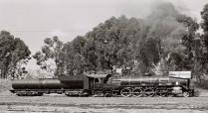

SOUTH AFRICAN NATIONAL RAILWAY AND STEAM MUSEUM

(Registered non-profit organisation NPO 003-922)

223, Northcliff House, Beyers Naude Drive, Northcliff, Johannesburg
PO Box 79249, Senderwood 2145
South Africa

Magaliesburg Express e-mail : alettalekalakala@telkomsa.net
Tel : 011 888 1154/5 Fax : 011 888 5394 Cell : 072 140 7800

Administration/finance e-mail : mikedyke@iafrica.com
Tel : 083 625 1879 Fax : 086 670 6434

Site manager e-mail : geoffp@netactive.co.za
Tel : 082 852 8246 Fax : 086 671 5370

(for international contacts, replace the first “0” with “27”)

NEWSLETTER NO 2 of 2012 – 31 May 2012

Dear SANRASM member

I have committed myself to make sure a newsletter goes out at least every two months. If I don’t do it, you have every right to fire me (unless fate intervenes!) This probably means that the newsletters will be a bit shorter, but at least they will be more up to date.

The response to the April one was very good – please keep up the input as it certainly helps to motivate us to do the things which we have planned or will plan to do.

Response was not only from members – the following appeared on the Railways Africa website (www.railwaysafrica.com):

“A modest (in size) but dedicated and hardworking group has revived the South African National Railway and Steam Museum (Sanrasm) in no small measure, following its unfortunate stormy patch during the recent past. The April newsletter is brimful with news, impressive listings of locos and coaches that have undergone or are in the course of extensive repairs, items slated for moving to other caretaker sites (including details of how these daunting tasks are to be managed), factual financial realities (of concern but more hopeful that one might expect), and other interesting and encouraging business. Key man Mike Dyke highlights the shortage of resources – ‘particularly human resources’ – as a big problem. ‘It is very difficult to find a back-up when the person responsible for performing a particular function is unable, for good reason, to produce results as quickly as we would like.’

The newsletter is copiously illustrated with photos of Geoff Pethick’s magic in coach restoration. Meanwhile, items beyond hope are being dealt with practically.”

[The remainder of the article consists of quotations from Geoff’s report.]

You will see that I am trying to include a few articles of historical interest, particularly where there is some present reference to those items (like the restoration of 2914 by Reefsteamers).

Any contributions by members or friends will be welcome, especially if they have interesting photos attached. All such contributions and photos will be acknowledged.

Randfontein sites

Open day 21 April 2012

On the first occasion for more than two years, the Randfontein South Site was opened to the public – although we were unfortunately not able to do anything more than show people around, answer their questions and tell them of our plans.

Apart from the Exco members, we had visits from steam enthusiast George Horn, modeller Andrew Heydenrych (who spent four hours taking photographs which he thought would be useful to him), long-term member Vic Theron, and Friends of the Rail chairman Steve Appleton.

Steve’s visit was particularly valuable, as we were able to discuss aspects of our future plans to relocate some of our activities to Hermanstad – more in the appropriate section.

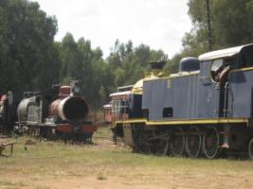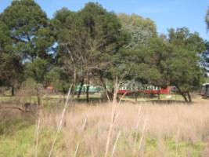

The site on 21 April 2012

Some of our visitors were accompanied by family members. The general reaction was very supportive and made it a good day for us.

If you wish to visit the site at any time, please contact Geoff (details on the front page).

Filming on site

We have had a number of approaches from various bodies requesting the use of the site for photography and filming. The following letter is, I think, worth passing on to all our members and friends:

“Dear Geoff and SANRASM staff

On behalf of my crew I would like to express my deepest and most sincere gratitude for everything that you have done for my crew.

When we first found your location we were blown away by the magic and mystery it held, thus making it the perfect location for our 3rd year experimental short film for our graduation at The South African School of Motion Picture and Live Performance (AFDA).

From the very moment we first step foot on your location to when we wrapped each and every crew member felt completely welcome and happy. You were the perfect location host and I can not thank you enough. You helped us in so many ways you can not begin to imagine. Your stories on each of the engines at your museum were mind blowing and I think all of us left with valuable information.

. . .

Thank you once again, Geoff.

Kindest regards
Nicole Kitt”

North Site

The clearance of the north site is virtually complete. It is proposed that the track will be moved to Friends of the Rail and the machines to Reefsteamers during June. After that we only have to have the site detoxed and restored.

There will be a saving in costs, since we shall no longer require security on the site.

South Site

Although Geoff was away for a few days, his team continued with their good work. When he returned, he took two photographs:

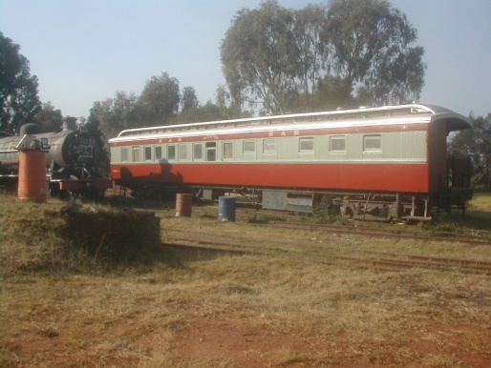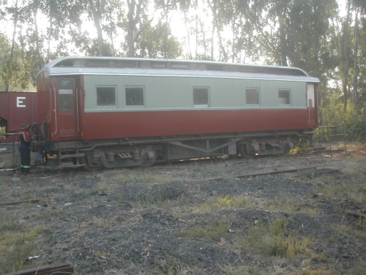

Phantom Pass Private saloon 15001
Photos by Geoff Pethick 16 may 2012

During the last few weeks we have made good progress with repairing and repainting the coaching stock. Phantom Pass has been finished, 15001 has been completely repainted and a start has been made on repainting Kitchen Car 282. New sets of decklight screens have been made for Phantom Pass and 15001 and work is well under way on a set for 282.

We’ve a set of replacement windows which need painting and varnishing for E-13 2123, twon sets of frames to assemble for 282 and 2783 and Colin Jenkins is currently with us with windows created from teak recycled from scrapped coaches. The first set of these is for Westvaal.

(Geoff’s comments)

The Magaliesburg Express

The April and May trains have been reasonably successful, although the May one was delayed by signal failures at Germiston and ultimately left Johannesburg some 20 minutes late.

Feedback from passengers is generally good, and we have received a number of comments on the excellent service provided by Aletta – I had a long conversation before the departure of the May 27 train with the head of a family who congratulated us on Aletta’s response when he phoned from Dubai to make his booking.

Reefsteamers have a new catering and bar service team who have upgraded the condition of the kitchen, which also attracted favourable comments from passengers (and from Aletta).

We are still obtaining good – mostly free – publicity. The article below appeared in Rapport on 15 April. It was brought to our notice by Reefsteamers, but it is obviously good exposure for both of us – particularly now we are proceeding with our joint operation for marketing trains.

It’s a pity the branch line from Pretoria is not still an option. I have often enjoyed riding on or chasing and photographing trains through Hekpoort in the past. I dream of how things could have been if that line became a dedicated heritage railway, as happened to many of the abandoned branches in Britain.

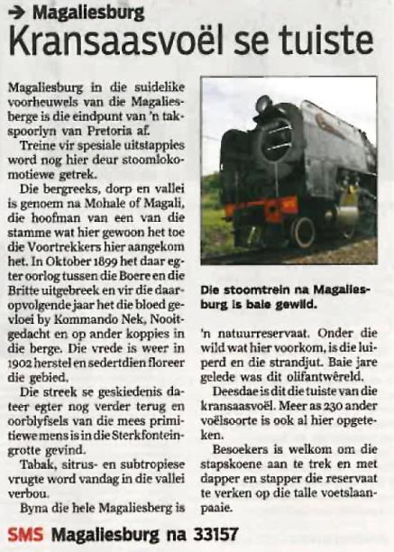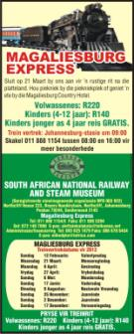

We have resumed our efforts to organise the operation of Magaliesburg trains as a joint venture with Reefsteamers – we and the Reefsteamers board believe this will be to the benefit of both organisations. The latest proposal means that we will share all income and costs on a 50:50 basis. All bookings will be handled by Aletta at the SANRASM office. I had a meeting with Reefsteamers chairman Dennis Edgar this week and hopefully the arrangement will be confirmed by a meeting of their board on 2 June (this did happen – all local trains will in future be marketed under ther name Magaliesburg Express).

Unfortunately, costs of operating the trains continues to become more expensive. Following an increase in the fee payable to Transnet Freight Rail for the operating permit (YQ) by 34%, from R9 009 to R12 086, we have just received notification of an increase in the coal price from R818 to R996 (22%). The standard locos that head our trains use about 12 tons on a Magaliesburg trip, so the additional cost will be more than R2 200; add the two increases together and we have to sell another 30 tickets to cover the additional cost.

At the moment, 15F 3016 is the only locomotive operational. The 15Fs are fairly expensive to run, and we anticipate that 12AR 1535 will soon be back with us. We have assisted by providing financial assistance for the replacement of boiler tubes required to put Susan back into service. The amount of roughly R14 000 will be offset against the restoration of our own locomotives, in due course. In the meantime, we will see a reduction in coal and water costs when she heads the trains.

Finance

We still, we believe, have sufficient funds to finance the moving of our assets and to start restoring some of the locomotives to operating condition. We received another R105 000 for the scrap remaining on the North Site, so we did not have to draw too much from our invested funds to finance our activities for April and May.

The annual financial statements for the year to 31 March 2012 are virtually completed and will be forwarded to members when they have been approved by the Exco together with the notice of the annual general meeting, which we plan to hold early in August.

We finally won a minor battle with SARS over a VAT refund which was due in December 2011. After going through the objection process, we finally received the payment (with interest) last week.

Membership

Membership now stands at 52 (including the four honorary life members). We have been able to welcome back a number of people who had previously been part of SANRASM. Norman Hogg from England is currently in South Africa and I had the pleasant experience of giving him a tour of the site.

Subscriptions

A reminder that the annual subscription for 2012 is R115 for the current year. So far 21 members have paid. May I ask those who have not already paid to meet their commitment as soon as possible.

SANRASM’s bank account details are:

ABSA Bank (all branches - code 632 005, where required) Account no : 40 4873 7756.

Account name - South African National and Steam Museum – please note that the banks require that the full name be written on manual deposits (we have recently had a couple rejected where abbreviations were used).

Please quote your name and membership number in making the deposit or transfer.

Books and other material

We still have a large number of back editions of the Courier (and its predecessor, Railway Preservation News, as it was known until 1994. Some even date back to the time when Geoff was the editor. These are available to members without charge, and to non-members at R10 a copy (excluding VAT). Please contact me with your requirements or visit the Northcliff office. We disposed of a number at the Open Day on 21 April, but we still have more than 20 copies of some issues. I have put together two sets for the Museum library; they consist of all issues from number 20 (December 1985 – when it was still called Preservation News and Geoff was the editor) to the final issue (number 134 in 2010). We will keep a maximum of 5 copies which are available to members (free), and will have to dispose of the rest to give us more space for the archives. If anyone has any issues prior to no 20, I would be grateful if they could provide me with copies for the archives.

I mentioned in the April newsletter that we are starting to build a library of railway books, particularly those dealing with railways in Southern Africa. Unfortunately, some of the books from Jack Sosnovik’s collection were not in very good condition. I have been able to replace some of them from my own collection. Others will be retained until we are able to replace them with better quality copies. Those which are replaced will be sold at a price which reflects their condition – some of them are well worth having, even if they are not visually very attractive.

Those available for sale will be listed in our next newsletter.

I repeat my request - if you have any books which you are prepared to donate to the collection, please let me know – or you can do what I have done – make the donation in terms of your will or tell your family that you would like your books to come to SANRASM.

A list of the books making up the library collection, which will be available on loan to members (subject to Ts and Cs), will be compiled and sent to members shortly.

Books which are for sale will be available at Northcliff.

Authors

Some of our members and friends are among the most distinguished of writers about South Africa’s railways. This seems to be a very productive period for them.

If any of you wish to promote your books in our newsletter, we will be very happy to do so. There will be no charge for this service (although we would be very happy to accept a donation of a copy of the books concerned as a contribution to the library we are in the process of building).

Other organisations

We are continuing to operate on the basis that we will work with other railway or heritage organisations where we have common interests.

We have applied for membership of the Heritage Railway Association of South Africa (HRASA) as we believe that, now we have sorted out (most of) our problems, we are in a position to make a contribution to their activities. They are likely to be involved in the disposal of assets by the Transnet Foundation, some of which have been identified as being appropriate for SANRASM to acquire. We have not yet received any response to our application.

Reefsteamers

Refsteamers have launched a project to restore to running order their 15F class 2914. This was one of the first batch of 15Fs, built in Germany in 1938. Unlike their later counterparts, built in Scotland, they were manually fired and were, for that reason, not as popular as those with the mechanical stoker. However, they outlived, in many cases, the post war version. Among the last 15Fs in commercial service were those operated by Rustenburg Platinum as late as 1993.

When my interest in railways revived in the 1980s, I was often confronted, on my way to work, with Henschel 15Fs shunting in Isando. These photographs of 2914 were taken by me during that period.

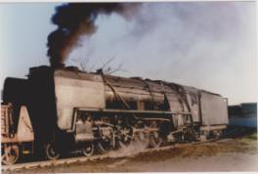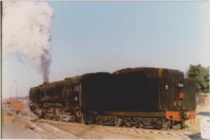

Isando 9 July 1989

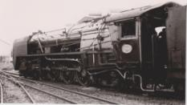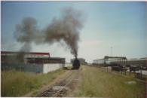

Isando 20 March 1987 Isando 28 December 1989

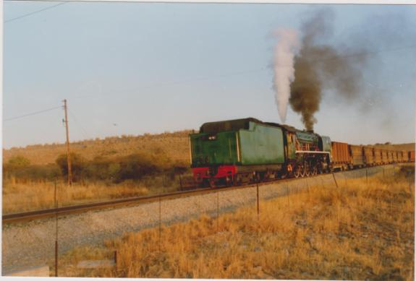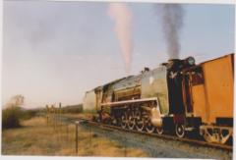

This is 2909 at Bleskop, Rustenburg on 29 June 1993 - looking very good.

If you wish to read more about 2914, or to make a contribution to its restoration, please go to
15F.2914@reefsteamers.com

The original target was R45 000, which has already been reached in terms of commitments and actual payments. However,the work done so far has revealed other items that need to be taken care of, so the target has been raised to R70 000.



Friends of the Rail

Steve Appleton was at the open day and we had a good opportunity to discuss many matters with him.

The executive committee met with the FotR board on 26 May at Hermanstad. We had a full and open discussion of the implications of SANRASM placing some of our assets at the Pretoria site, and to assist in completing the move of their assets, together with our class 19D no 3366, from Capital Park to their new site.

The immediate requirement is the transfer of the track from the North Site, to accommodate the items moved from Capital Park. This is planned to take place in the near future.

We are working on plans for the installation of basic workshop and storage facilities at Hermanstad, which will be for the housing of our locomotives and coaches from the South Site. Those coaches which are roadworthy will be available to FotR for use on their Cullinan and Tshwane Explorer trains, which we will probably be assisting them in marketing.

Steam in Action/Sandstone

Because of the failure of HRASA to make any progress in the involvement of the Transnet foundation or other state entities in assisting us with our activities aimed at promoting public interest in railway heritage, and the protection of remaining assets, the Sandstone Trust management are reviving the Steam-in-Action campaign. We would like to encourage our members to support their programme wherever they have the opportunity.

The past

The museum sites at Randfontein have quite a past. One of my other interests is the history of the mining industry on the Rand – I recently acquired a book which was published in 1986 to celebrate the centenary of the Randfontein mining operations - Randfontein Estates – The First Hundred Years, by Anthony Hocking.

The following extracts from the book are published by kind permission of The Randfontein Estates Gold-Mining Company, Witwatersrand, Limited:

Back in Business
(p 211)

Late in 1974 the Cooke Section rail link was completed, and the company’s private network returned to full duty. Randfontein had retained several of the old locomotives and tank engines used before the mine’s closure, and in addition acquired two class 1 4-8-0s and two 15BR 4-8-2s from South African Railways. The four locomotives were overhauled in Randfontein’s workshops and the 4-8-0s were refurbished in the company’s livery, bright blue with yellow boiler bands and the initials ‘REGM’ in yellow on the coal tenders.

The first reef produced from Cooke 1 had been hauled in September 1974. By November, the two 4-8-0s were in regular service and the first of the 15BRs was ready for commissioning. The rail network was controlled by radio from a despatch office at Millsite, through two-way radio equipment carried on each locomotive. Unfortunately one of the drivers misunderstood a crucial message, and as a result there was a head-on collision between the 15BR and one of the 4-8-0s. Nobody was killed, but both locomotives had to be written off.

Gathering Steam
(pp 235 – 236):

Close to old 3 North shaft, three hectares of Randfontein’s freehold are leased to the Railway Society of South Africa which has used the land to set up its railway preservation centre. Aged locomotives, tank engines and coaches acquired by the society, many of them only partially complete, are restored to their original glory and put through their paces on a section of the company’s private network. One of the society’s special prides is an elegant dining car, ‘Phantom Pass’, which dates from the 1910s and can still be used.

Of course, in setting up the preservation centre society members were well aware that the whole of Randfontein was a rail museum. The two mainline stations, Randfontein and Robinson, had changed little since the years before World War 1, and the mining company’s fleet of locomotives still included several steam engines that were more than 40 years old. Then in the early months of 1983 the company bought five GMAM Class Garratts, some of the most handsome and powerful locomotives ever used on South Africa’s main line services.

The five Garratts had been retired because South African Transport Services was moving out of steam. They were needed on Randfontein because the company was extending its rail network all the way to Cooke 3, in the process replacing the overland conveyor between Cooke 2 and Cooke recovery plant which was already overloaded. Each of the Garratts weighed 193 tons and was capable of pulling 15 50-ton hoppers as well as a weighty water tanker, making up a unit that stretched 200 metres down the track.

Four more Garratts were on order, and Randfontein’s management planned to name them after the wives of directors, starting with Kathy Waddell. Not long afterwards Gordon Waddell visited Randfontein along with a large party from Johnnies and took special interest in the Garratt called ‘Kathy’. Later ‘Kathy’ was connected to a special train including the railway Society’s ‘Phantom Pass’ and took Waddell, his party and a number of the mine’s senior managers on a tour of Randfontein and Cooke.

The party’s host was a new general manager, Wally van der Meulen, himself a keen steam enthusiast who had grown up in the Eastern Cape and had been a learner official at Randfontein in the 1950s.

The article awakened a number of memories for me. In 1985 I revived my childhood interest in railways, particularly steam. (I had grown up almost next door to the Southern Railway’s works at Eastleigh in England). I had three regular Saturday morning destinations – Germiston, Springs and Grootvlei, and Millsite and Randfontein. By that time the Garratts were well established and provided many opportunities for some spectacular photographs.

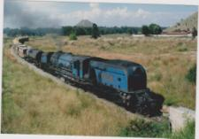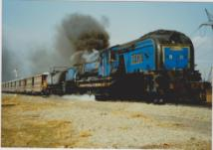

R8 ‘May’ (SAR 4130) approaching Millsite R11 ‘Vivienne’ (SAR 4123) powers through
on 14 February 1987 Doornkop Junction on 21 July 1990

I had no idea where the names for the locos came from, and I was interested to learn of Gordon Waddell’s involvement – I was at university with him in the 1950s. ‘Kathy’ (R9) was SAR number 4128, and I have many photographs of her and her sisters. This is ‘Kathy’ leaving Cooke 2 on 27 September 1986.
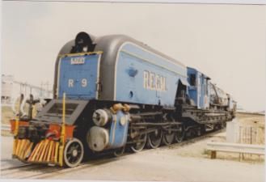

There were still some older locos around – like R7 (15BR 1990) – still with us, fortunately, - here seen at Cooke Plant on 4 January 1989.

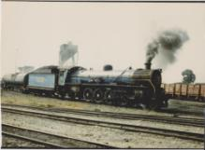

When I came back from working in the Middle East at the end of 1989, Randfontein was, not surprisingly, one of my first places to visit. On the morning of January 1, 1990, I was lucky enough to drive past Cooke 1 just as the ‘directors’ train’ was approaching and I met it at the road bridge. This one was hauled by R14 (‘Joan’) – SAR 4135 - with the two SANRASM dining cars.

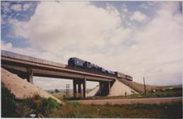

The future

It is interesting to hear other people’s views on the future – you start to realise that, although the scale of our operations is very small compared with countries like Britain, our problems are not by any means unique.

These comments by David Morgan MBE, Chairman of Britain’s Heritage Railway Association, appear in the April issue of Britain’s Railway Magazine:

“All change, please”

These words once signalled to me that the train or bus I was travelling in had arrived at its destination and all its passengers needed to get out. Nowadays, it is increasingly an expression I use myself – and I am not talking about changing vehicles. Most of us involved in heritage railways are often, by nature, averse to change; after all, we mourn the day when steam was replaced by diesel or electric traction.. However, an organisation that is unable to change with the times is surely doomed to die, which is not to say that all change should be embraced without good cause.

I know full well which members of my own teams will resist change, whichever benefits change may bring with it. Members of the ‘Not Invented Here Club’ abound in all walks of life. While the elderly may be more resistant to change, the younger generation is by no means immune to dropping anchor to fight any forward movement, if only because, somewhat surprisingly, the young can be more risk-averse than the old, who are often brought up in the school of hard knocks.

This is hardly surprising as health and safety would have us wrap up the young in cotton wool so that the first exposure they have to risk is when they reach the age of 18. Having said that, I am a great believer in empowering the young and delegating authority, as well as responsibility, to them. Managing succession is not always easy but it is vital that we succeed in handing the mantle down the generations. By and large, the young are more open to new ideas; their problem is that sometimes they don’t have the necessary skills required for the maintenance and operation of old and traditional equipment we use on heritage railways.

Training initiatives

This is highlighted by some railway manager or other being so preoccupied with the day-to-day operations that they do not have time to raise their eyes above the buffer stops at the end of their line to observe the world around them or to look into the future. It is for this reason that I am a supporter of the various training initiatives now being undertaken by the Boiler Engineering Skills Training Trust (BESTT) and the National Skills Academy – Rail Engineering.

Both these organisations are addressing the problems of training and of developing the idea of apprenticeships, which at last seems to be espoused by our Government. The other problem, which I suspect will hit us sooner rather than later, is the question of old equipment becoming worn out.

Many of our steam locomotives are not as reliable as they used to be for a variety of reasons, not least the fact that they may only be used on an occasional basis (i.e. they may only be steamed at weekends, which allows the hardware to be heated up and then to cool down, causing expansion and contraction on a regular basis, whereas in the old days they would remain hot for days on end). This was brought home to me by the engineers involved in the SAT Project, who pointed out the more frequent causes of locomotive failures and why their proposal for an all-new design could be one way of answering this.

Sooner or later we may well be driven to building new steam technology once so forcibly espoused by the great engineers of steam such as André Chapelon and Livio Dante Porta.

- - -

Obviously, the development of new steam technology is something which is unlikely to happen in our ranks (but who knows?). There are, however, a number of topics there that we should be directing our thoughts to. Perhaps HRASA should get involved – I have not seen anything in their reports to suggest that they have taken any action in this field - and we would lend our support.

All photographs included in this newsletter are by Mike Dyke, unless otherwise acknowledged.

Mike Dyke
Chairman, SANRASM Executive Committee

Executive committee contact details:

Cellphone e-mail

Mike Dyke 083 625 1879 mikedyke@iafrica.com
Tony Attwell 083 629 8732 tony@alacc.com
John Hammill 082 441 5934 lusikisiki@worldonline.co.za
Joe Lekalakala jojomalose@gmail.com
Geoff Pethick 082 852 8246 geoffp@netactive.co.za

