STEAM TRAIN PHOTOGRAPHY
Friends of the Rail
Preserving South African Railway Heritage
Presents
A weekend of
Steam Train Photography
Dates: 13 – 14 June 2015

Venues: Capital Park Steam Shed Tswane/Pretoria, and Cullinan Branch Line.

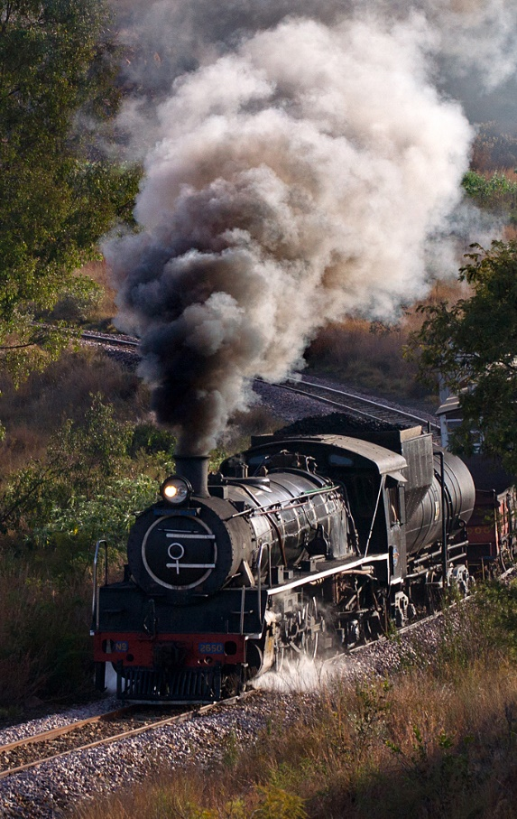

Program:
Saturday 13 June:
06h00: Sunrise Photography at Capital Park Steam Shed with Class 24 No 3664
Late morning departure for Cullinan.
15h00: Afternoon Photography on the Branch Line. Sunset on the line.
Night Photography at Cullinan Station. Flood lighting provided.
Sunday 14 June:
06h00: Sunrise Photography leaving Rayton.
15h15 Departure for Pretoria.

Cost: Just R1750 per Photographer.
Not including meals and accommodation, which can be arranged. Accommodation on the train is also possible this year. Non-photographers can be accommodated at a lesser fare.

Contact:
David Benn
david@shrinks.co.za
or
Arno Victor (Friends of the Rail)
sales@friendsoftherail.com
+27- 12 7678145
http://www.friendsoftherail.com

The weekend will be led by experts in Steam Train Photography.

By participating you will be supporting the preservation of Steam Railways.

This is not to be missed .
Subject to a minimum of 40 bookings – Maximum 50.

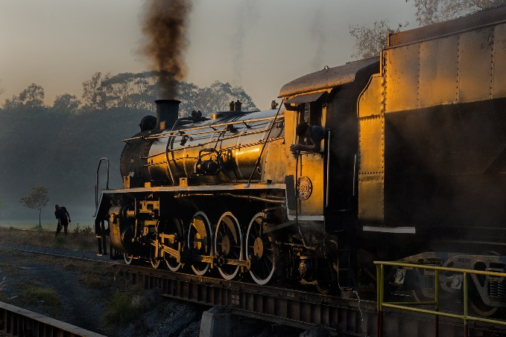

Winter is traditionally the best time for Steam
train Photography – the weather is usually
cold and clear, with excellent steam effects
for the best photography!
(Obviously good weather cannot be guaranteed)



