Mrs Pam SPARROW pamsparrow44@hotmail.com
01453 759540

TENDER TRAVELS

Opportunities – they are moments that must be taken as they make up the rich tapestry of life and the memories and joy created continue to live with us for ever.

I am a ‘railway’ daughter because my father worked for the East African Railways and Harbours after being demobbed from the army having spent the war in Abyssinia and British Somaliland. I was born and brought up in Dar-es-Salaam in what was Tanganyika, now Tanzania, and also lived in Kenya.

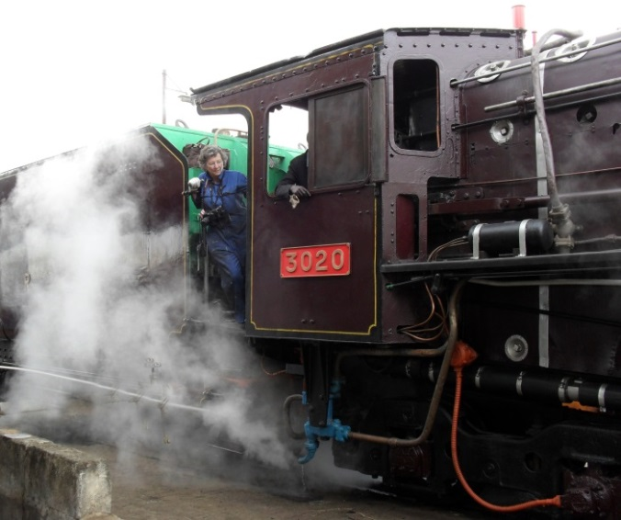
There was an opportunity in May 2011 for me to go on a week’s steam railway safari in Kenya and before I left the UK I received an e-mail from my friend who had a hand in organising the event, saying ‘bring a pair of trousers as the engine could be dirty’. A fleeting thought crossed my mind so I dutifully packed a pair of trousers.

On arrival in Nairobi Kevin told me that the following day I would be travelling on top of the tender for the dead leg from Nairobi to Naivasha, something the anoraks would not be allowed to do on their journey back to Nairobi the next day. Owing to problems with taking water on board we did not leave Nairobi until 10 to 2, four hours late.
On the footplate of steamed up 3020

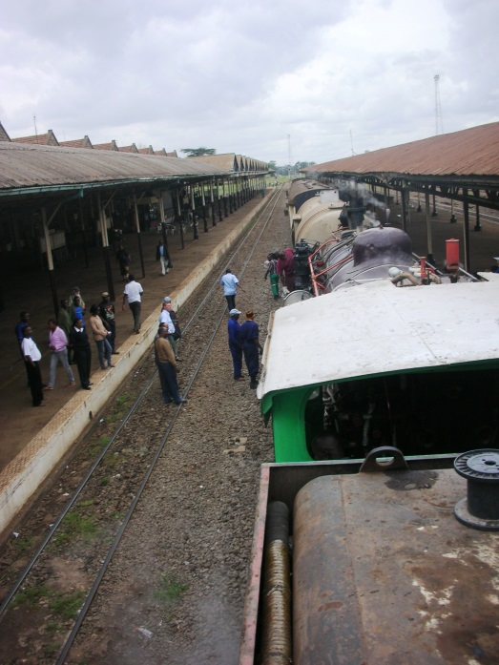
Our departure from Nairobi was watched by a crowd of intrigued and interested locals all photographing this very unusual sight as steam had not been seen in Kenya for over eight years. However, I was invited to blow the whistle announcing our imminent departure so I scrambled down to the foot plate to blow the whistle – it was very hard and took a great deal of strength - and knack - to pull the cord and play the tune, but I did it!
With some of the crew
Waiting to leave Nairobi
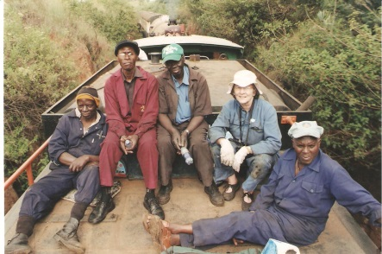
I was the only woman on the train; the other travellers being the African crew of about 10 which included the supernumerary who would work the return to Nairobi, a couple of the anoraks who had special dispensation to do the journey both ways, the three European men who were there to make sure things happened, not always successfully but then TIA, (That Is Africa) and a couple of others involved in the organisation.
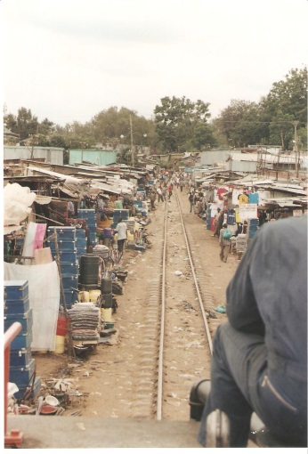
These days the narrow gauge tracks are not well maintained and at several points en route there was evidence of derailments mainly due to the locos being driven too fast on the narrow gauge. On the outskirts of Nairobi we went through the Kibera slum and nothing, but nothing, can prepare anyone for seeing it for real. As far as the eye can see, and beyond, there is just a continuous sea of rusty corrugation which passes for roofs, each house so close that probably the alley ways are only a fireside armchair wide. People, animals and rubbish were constantly across the line so we were deafened by the insistent shrill whistle. However, the people were all so friendly and returned our waves with wide smiles, but there were just two fleeting moments when I felt very vulnerable and just hoped the two African armed guards on the train were ready – their guns were very much in evidence on their shoulders. They were great fun and I had a laugh with then the next morning in Naivasha. However, there was no problem, but it took us about 15 – 20 minutes to pass through this awful area into the African countryside of small holdings of maize, bananas and other cash and self sufficient crops, isolated dwellings and lone Africans watching in amazement as we passed by especially to see a mad mzungu (white/foreigner) memsahib on top of a railway tender.
Passing through Kibera

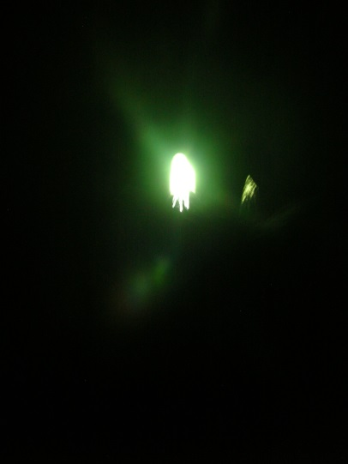
Nairobi is 5,000’ high and as we climbed ever higher and higher it started to cool down considerably and by the time we reached Naivasha in the Rift Valley we were well over 6,000 feet. As we travelled we had to watch out for overhanging branches and lie flat on the tender, though at one point I was not quite flat enough and the branch caught my face, fortunately I was in the right position otherwise it would have taken my glasses. We had to lie even flatter when we went through a fairly long tunnel as we had no idea as to what might be hanging down. On entering the tunnel there was no light at the end, but eventually we saw a pinprick which became bigger and bigger and I took the risk of raising my head sufficiently to take a photo of the light at the end of the tunnel. That was quite an experience.
Light at the end of the tunnel

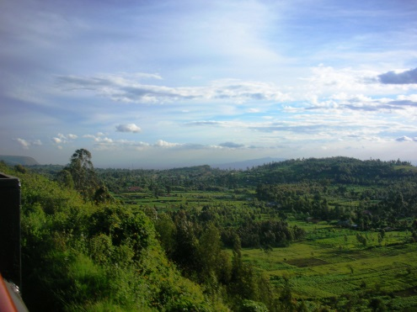
Just after this we had our next WOW experience; we left the verdant small holdings and arrived at the top of the Rift Valley escarpment. The vista went on for ever, MMBA, Miles And Miles Bloody Africa. (A phrase used by WWI British troops). We could see various volcanic mountains and on the side of the verdant escarpment it was patch-worked with more small holdings.
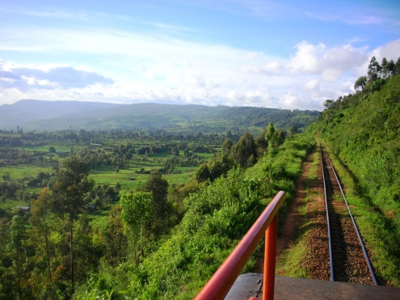
By now we had been going for nearly four hours and it was very cold and beginning to get dark so I manoeuvred myself down to the footplate for the last two hours and enjoyed the warmth of the firebox along with nine others. It was a small engine so we were very crowded on such a small footplate.
In the Rift Valley
Still the Rift Valley
At 8 pm we arrived in Naivasha, six hours after leaving Nairobi, but not sure quite how as neither of the engine’s headlights worked so we could have hit anything, especially as we were travelling tender first and Ben, the driver, was looking out of his window at the scene just passed – but as I say TIA. There was a wonderful welcoming party to greet us and I had a particularly special welcome. I was very, very tired, even dirtier and extremely hungry because all I’d eaten since breakfast had been two Fox’s glace mints, but I had taken water.

However, all that paled into nothing for the experience I had just had the good fortune to enjoy. We then collected all our belongings from the tender and walked the few yards to the hotel and fell on dinner still dressed in our dirty overalls to enjoy the local fish from Lake Naivasha.

Weeks later I was still on top of that tender enjoying the peace, the 360° degree views and the ever changing country, the isolated homes and small rambling untidy towns we passed. Opportunities are there for the taking – don’t hesitate otherwise it will be just a regret.

When I returned to the UK and took the high speed train home I felt it was rather pathetic sitting in an air conditioned carriage on well upholstered seats travelling at high speed. Excitement and thrill were definitely missing, but not my happy memory of an experience of a lifetime.
- * **
Footnote. In the 2015 Gryf Rees-Jones ‘Slow Train Through Africa’ series the engine used in Kenya was 3020, the one used to take us from Nairobi to Naivasha and Ben was our driver then and drove the train for Gryf.

