No 3451 needed then to be moved to the nearest point of safety, this being some 40km away at Reefsteamers [steam club] in Germiston. We are fortunate to have already in place, an MOU with Australian based member, inter alia, that he will finance initial movement and storage, without which nothing could have happened. Reefsteamers were thus contracted to prepare, roadworthy, transport & store No 3451. Firstly we thank our “financier” secondly Shaun Ackerman & Reefsteamers for executing this move professionally and safely.
So on Sunday June 19th 2016 Reefsteamers provided a live steamer 15F No 3052 at Millsite and along with similarly derelict Class 19D locomotive No 2540 “loaned” by T.F. to them, safely towed both locomotives at 30k.p.h across to Germiston arriving just after 17.00. William Higgo, our Kimberley mechanic, accompanied No 3451. Two further points of interest arise ! Firstly No 3052 was donated by S. A. R. at Kimberley in 1989 to world renowned wildlife artist, UK resident David Shepherd ! Who has recentlyentrusted his locomotive to SSR. Secondly this is possibly the first ever visit of a “Condensor” to Johannesburg station [Hbf] !
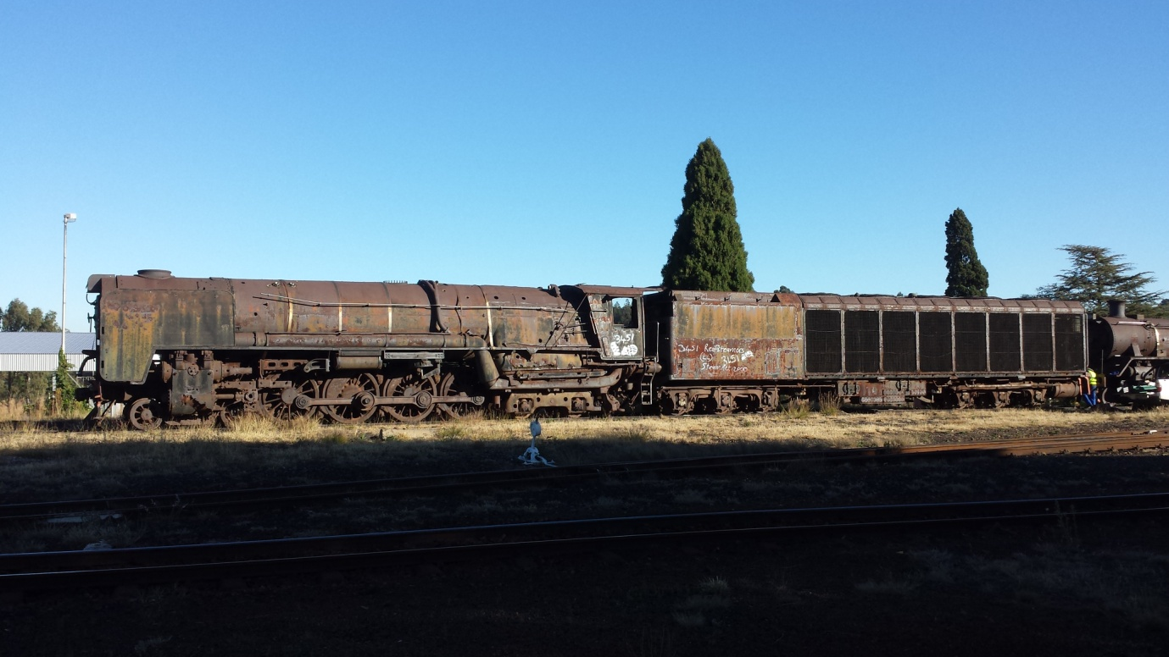
Here at Millsite No 3451 basks in early morning sun, Friday June 17, and later Transnet Freight Rail diesels move it into the workshop for “roadworthy”
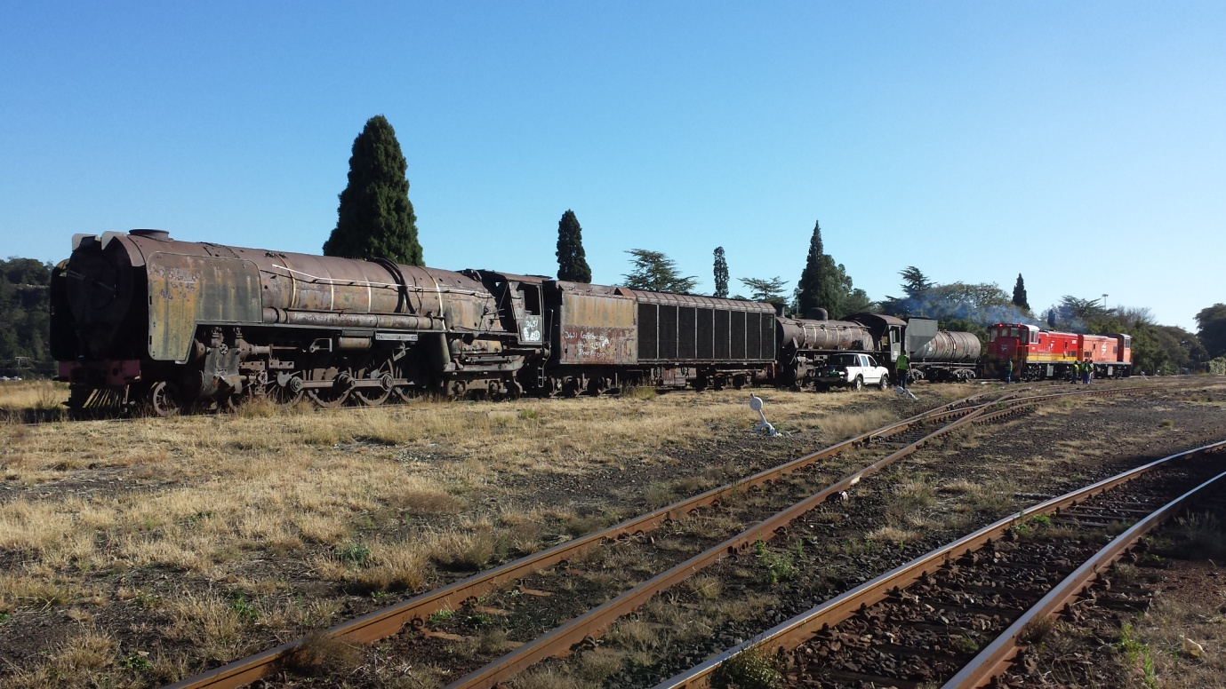

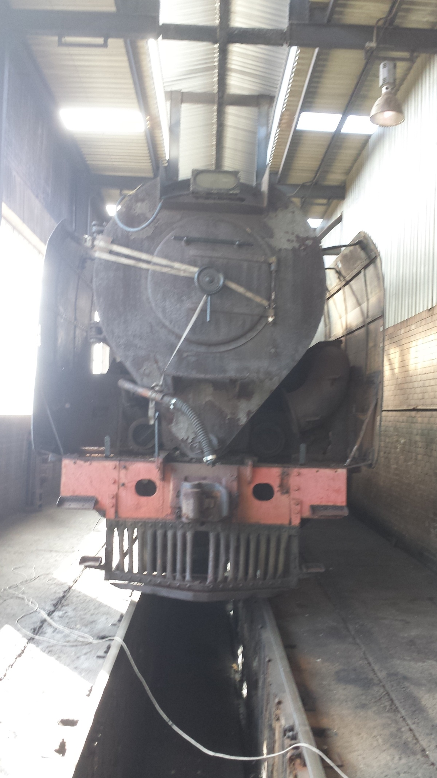

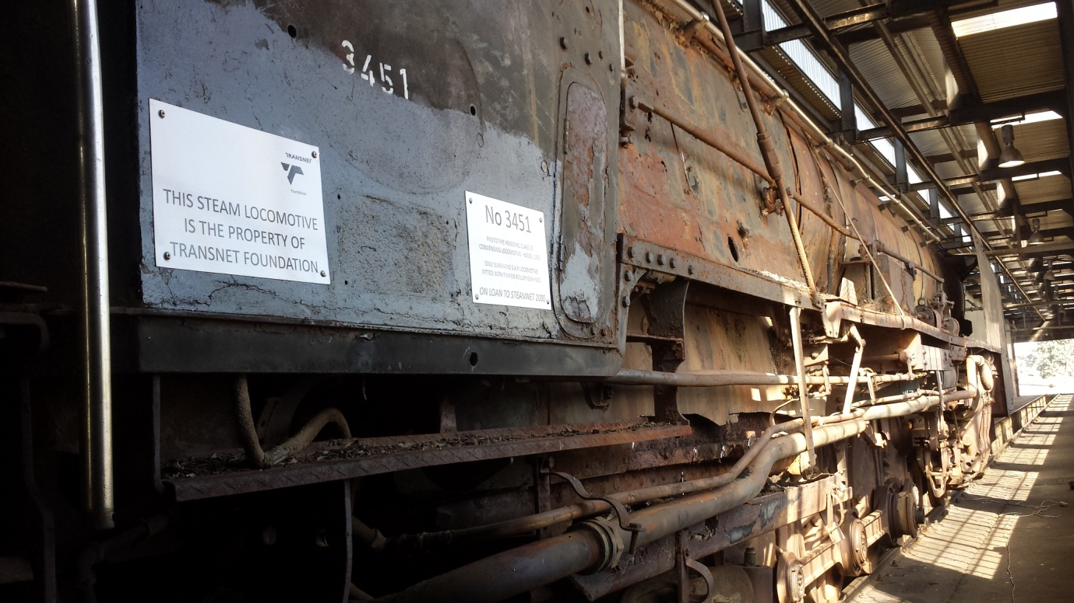
And on the afternoon of Sunday June 19th. No 3052 tows both locomotives out of Millsite to a new future. [photo Aidan McCarthy]
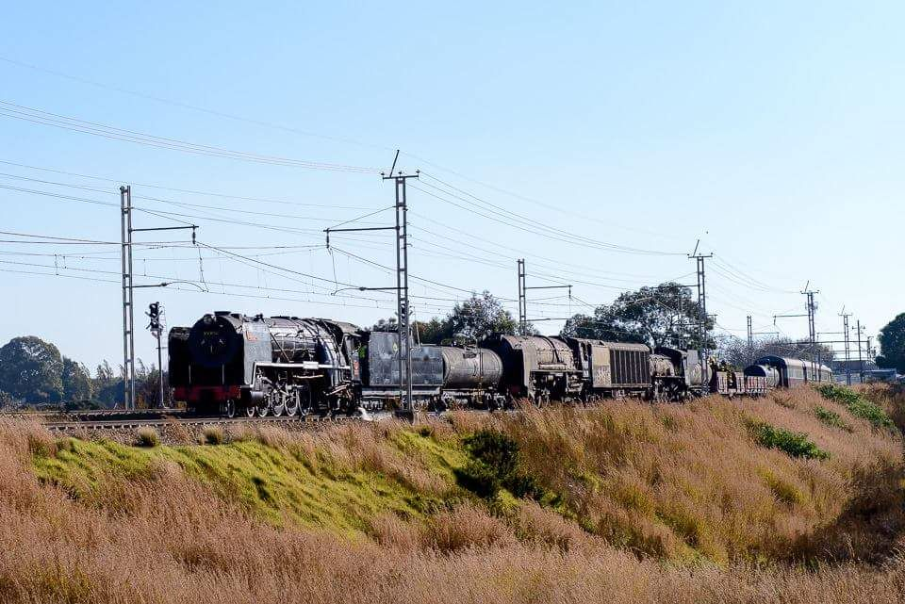
Futher restoration depends on available funding………………..

