1 February 2017

Report : Cullinan / Rayton Branch Line Weed Spray Project

The branch line from Cullinan to Rayton was very badly overgrown with weeds. SWC Vegetation Management and Arysta LifeScience kindly sponsored the project to eradicate this problem as a donation to FOTR and Heritage Railways.

Below is the custom built Nissan UD85 used to do the spraying.
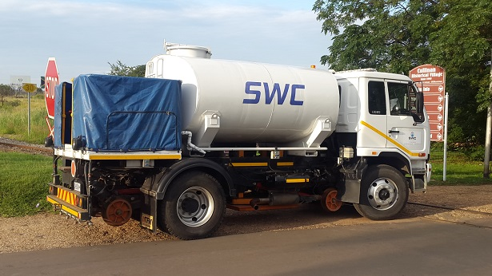

Gerhard Bouwer owner of SWC and Les Labuschagne of FOTR led the initiative.
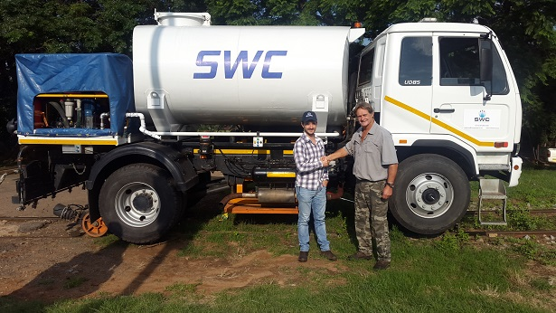

The team that worked together on the project back row from left to right: Blackie (Transnet), Alfie (Transnet), Andre (SWC), Gerhard (SWC), Phillip (FOTR), Mario (Arysta), Hans (FOTR).
Front row: Spikkels (FOTR), Kobus (FOTR)
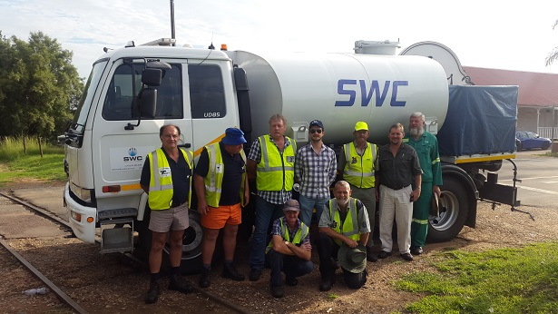

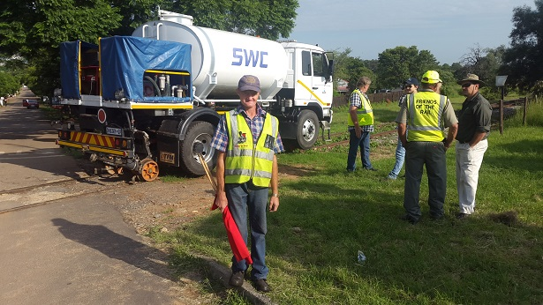

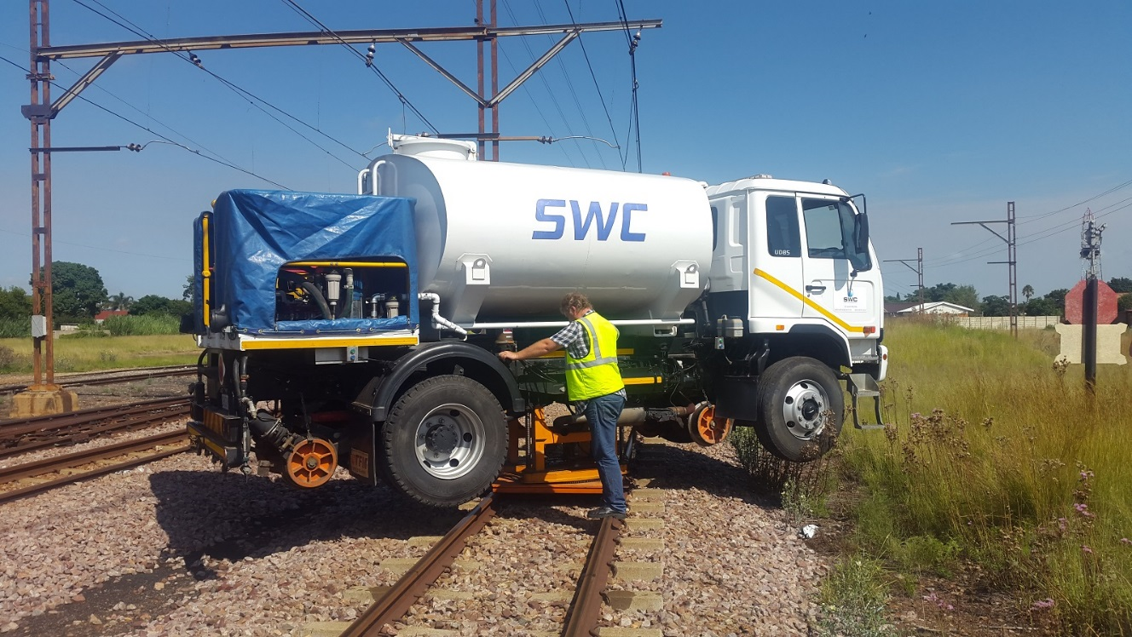

Once we reached Rayton, the truck was turned on its own turntable for the trip back to Cullinan.

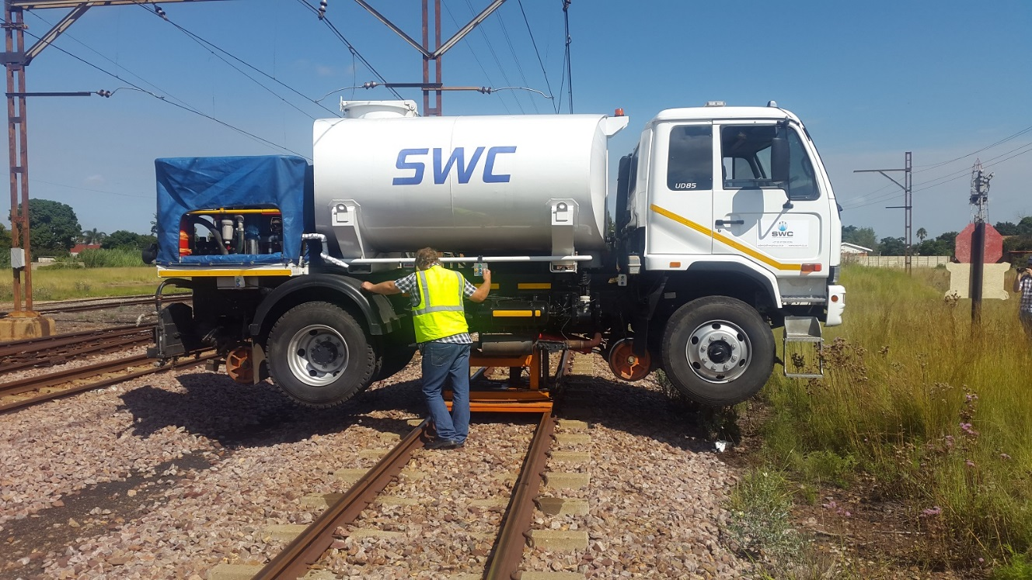
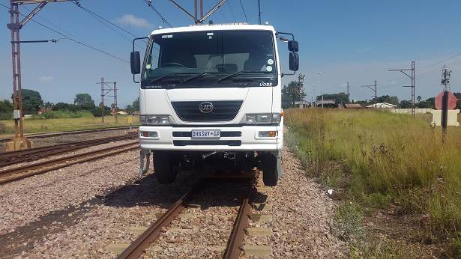

Arysta LifeScience kindly donated a cocktail of chemicals to treat a variety of vegetation that was growing on the line.

SWC Vegetation Management kindly donated their equipment and time to execute the weed spray. The line was treated from Cullinan, including the triangle, to Rayton platform and again on the return trip to Cullinan.

5000 litres of chemicals was used on the line, and the amount of product sprayed per hectare was 400 litres. The line was treated 3 meters either side of the centre line of the track. Within the next week the vegetation treated will start to turn yellow and die. Two different types of ground sterilisation chemicals were used to halt any further germination of vegetation. These chemicals enter the ground under the ballast, and form a sterilized barrier.

As the line has had a double treatment, the next treatment will be required around September 2017. Gerhard very kindly offered to also sponsor this second phase of the project for FOTR.

FOTR greatly appreciates the time and effort that has gone into this sponsorship by SWC and Arysta. I would also like to thank the Transnet personnel and the FOTR volunteers for their help on the project. Well done to all.

Les Labuschagne
FOTR

