NBL Preservation Group

Honorary President Professor Dugald Cameron OBE

July 2021 Newsletter

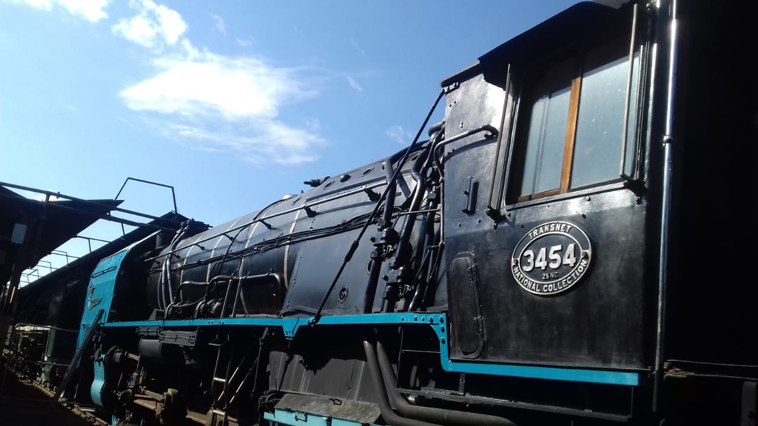

25NC RESTORATION (photos courtesy of Ian Welch)

Ian Welch has kindly sent several recent photos of North British 25NC 4-8-4 No 3454 ‘City of Kimberley’ which he has on a Lend / Lease basis from the Transnet National Collection. Considerable effort has gone into the restoration of this superb machine at Bloemfontein and we look forward to receiving more news in the near future. Quite incredibly, No 3454 (NB 27314) is not Ian’s only 25NC as he acquired No 3508 (NB 27368) from the Enyati Railway and arranged for it to be shipped to New Zealand where it is currently stored awaiting completion of MainLine Steam’s new depot at Mercer. We will bring you news of this ambitious development, which will comprise of a 16 road roundhouse and a carriage shed, as construction takes place.

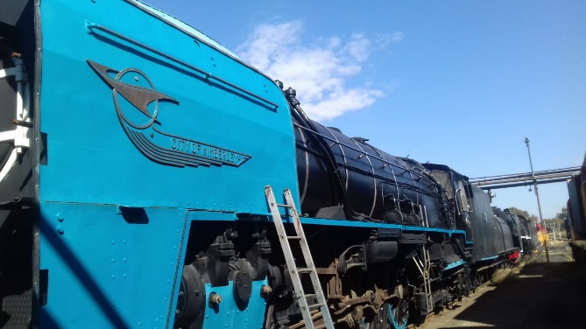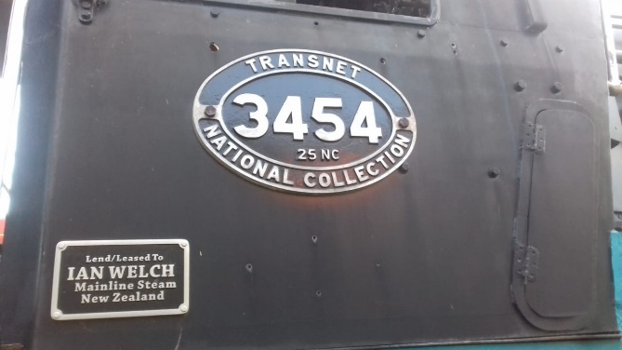

(2)
1970’s SCENES (photos : Roger Griffiths)
Many thanks to Roger Griffiths for these interesting photos of two North British steam locos in action in the 1970’s, these being LNER B1 4-6-0 No 61306 (NB 26207) and WD 2-10-0 No 600 (NB 25437).

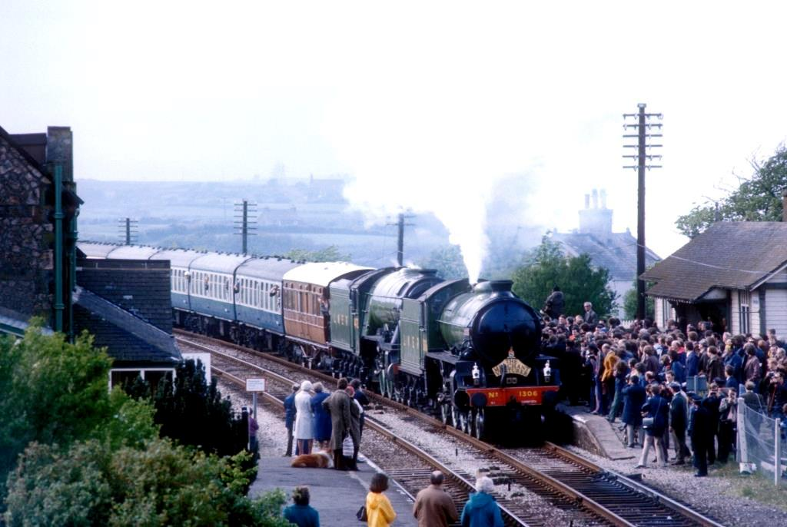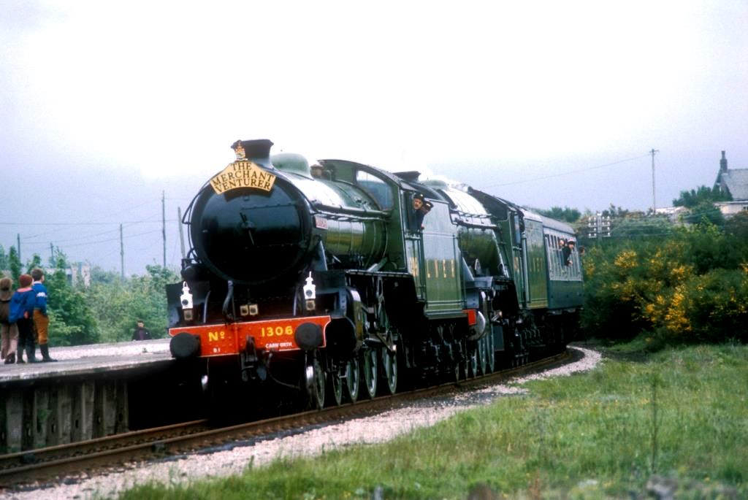
The LNER pairing of ‘Mayflower’ and ‘Flying Scotsman’ are seen double heading the ‘Merchant Venturer’ special at Ravenglass and at Foxfield on 22nd May 1976. Steam tours along the Cumbrian coastline were very popular at this time with a good pool of locomotives being based at Carnforth for these duties. Such trains would often visit the very scenic Ravenglass & Eskdale narrow gauge line.

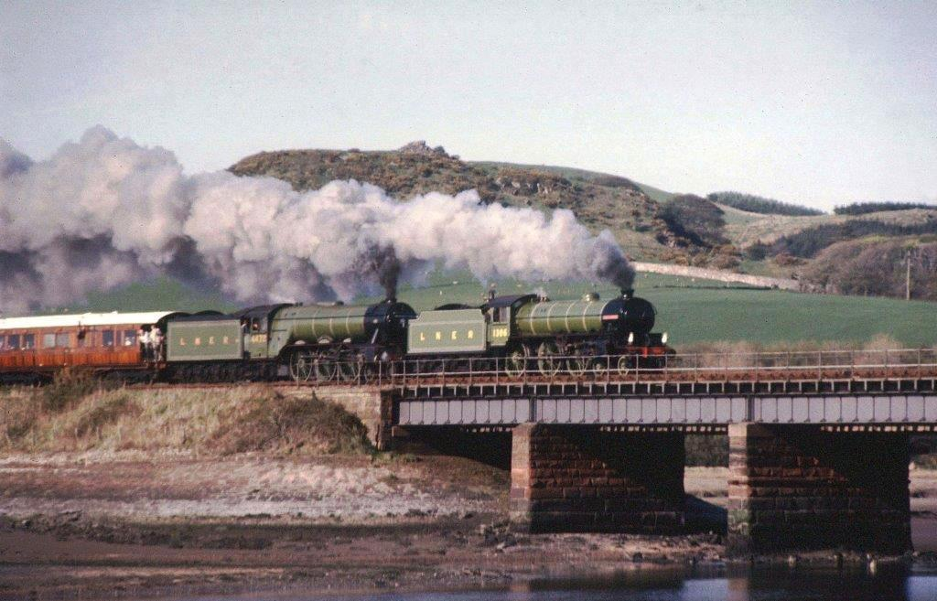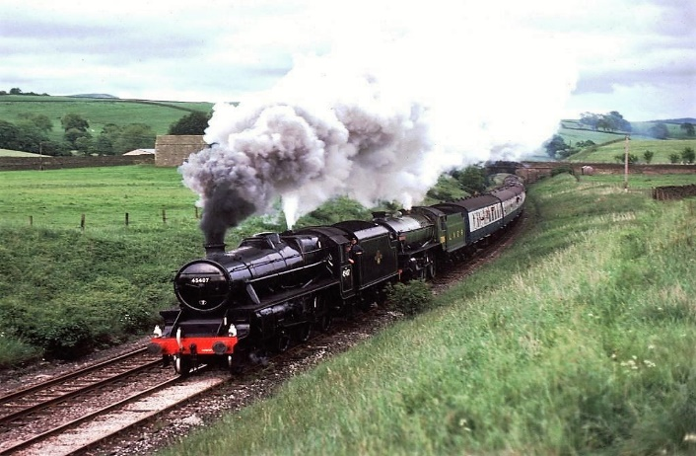
The following day 23rd May, the same pairing are captured working hard over the River Esk at Eskmeals. In the fourth photo 61306 was coupled inside LMS Black Five No 45407 on the approach to Giggleswick on 19th June 1976. Giggleswick is the last station before Settle Junction on the famous Settle & Carlisle Railway so hopefully the passengers were in for a treat !

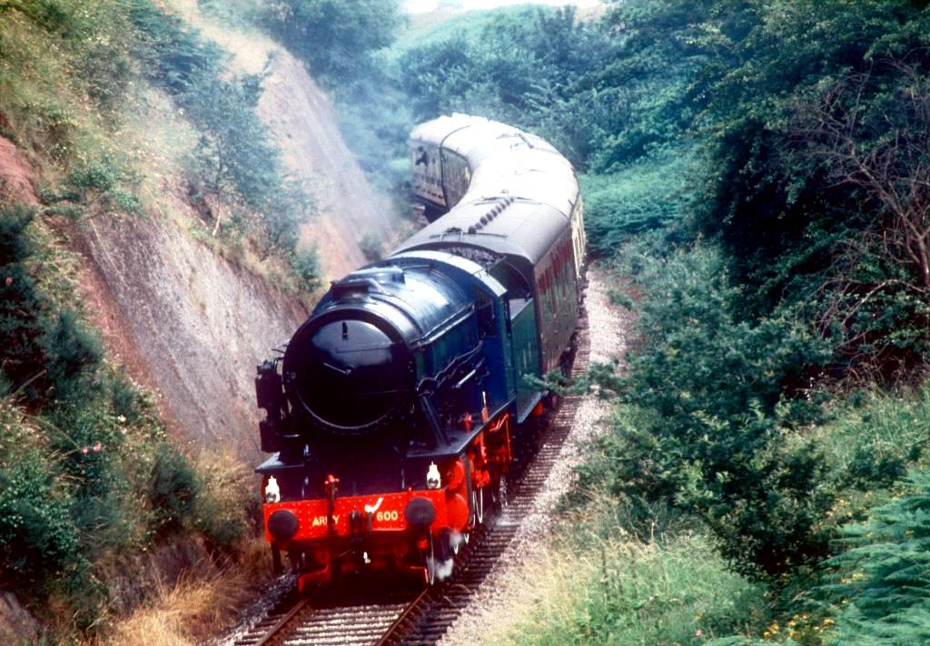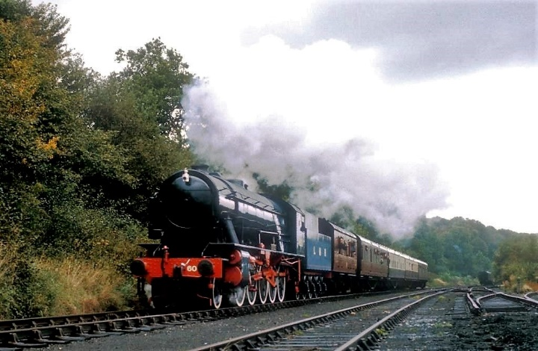
Further south, Roger photographed WD No 600 Gordon on some of it’s first revenue earning services on the Severn Valley Railway. Built for the War effort, No 600 (NB 25437) was based at the Longmoor Military Railway and used for crew training. After the LMR line closed in 1969, No 600 was eventually sent to Bridgnorth on the Severn Valley for preservation. Named after General Gordon of Khartoum No 600 was the last steam to be owned by the British Army and was officially presented to the SVR in July 2008.
(3)
PORTUGUESE 2-8-0’s (notes & photos from James Waite)
The railways of Portugal can’t be regarded as big customers for North British with only 3 orders taken during the lifetime of the Company. However, James Waite tracked down one of the second batch of 2-8-0’s during a visit to the country in August 1970. We are indebted to him for these very interesting notes photographs.

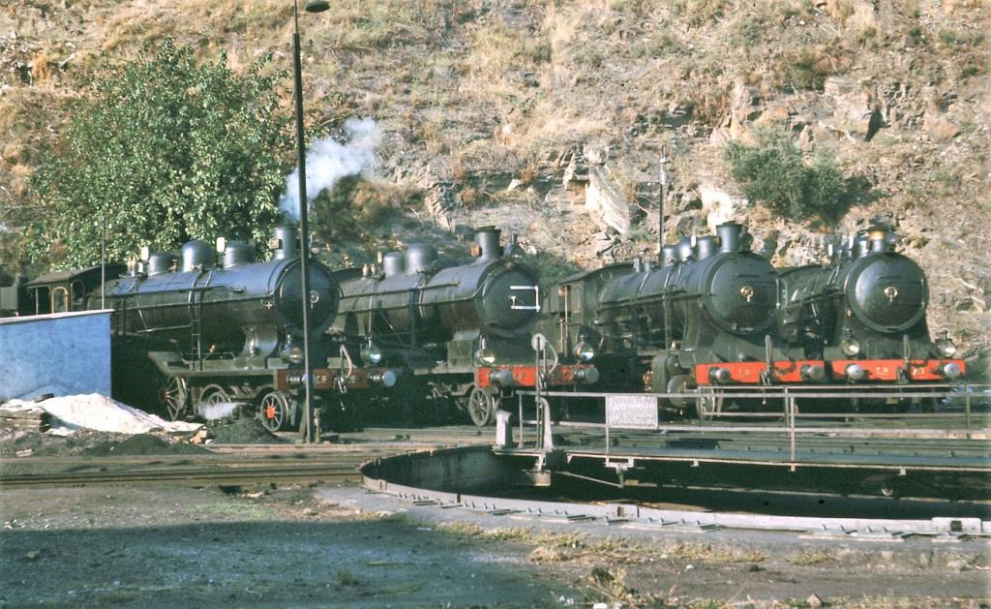

James will take it from here : In 1921 NBL built a series of eight 5ft 6ins gauge 2-8-0s for the Companhia Portuguesa, the main Portuguese railway company. They were numbered 1712-1719, and were later renumbered 712-719. They were part of a larger class built from 1912, the first ten having been built by Schwartzkopff. Some of them, including CP No 713, remained in use until the last years of steam on the Portuguese broad gauge in the early 1970s. I encountered No 713 (NB 22709) at Nine engine shed, about 30km north of Porto, in August 1970, and again at Regua, in the Douro valley, three days later.

Here are four pics showing CP No 713 - easily distinguished by her copper capped chimney. The first two are at Regua, in the Douro valley where the loco was one of several in the loco yard there. Next to her was No 703, one of the Schwartzkopff-built members of the class. The two 4-6-0s are No 281, an unusual inside-cylinder loco built by Henschel in 1910, and No 238, a 4-cylinder compound built by Borsig in 1904. There are also some metre gauge locos and a broad gauge 2-8-4T. The other two photos show No 713 standing outside the small engine shed at Nine, north of Porto where the branch to Braga leaves the main Minho line to Viana do Castelo and the Spanish border. All these photos were taken in 1970, when I was a student!

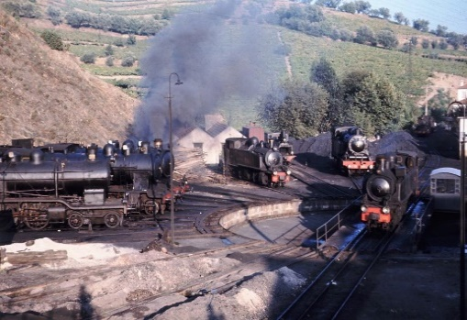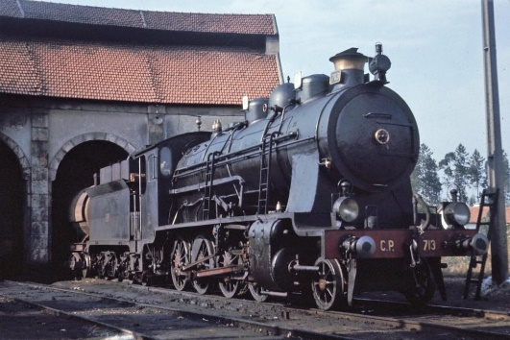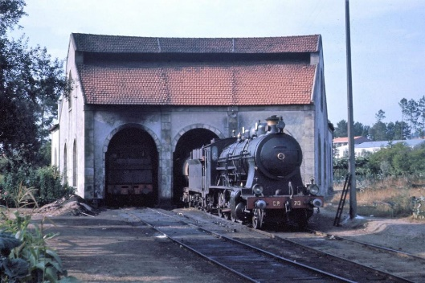

Many thanks for this James - several meter gauge steam locos remained dumped at Regua until at least 2016 but the only North British locomotive to survive in Portugal is the Estoril Bo-Bo Electric at Entroncamento.
(4)
FAMOUS 15’s (main photo : Phil Braithwaite)

With 255 examples built between 1938 and 1947, the 15F Class 4-8-2’s were South African Railways most numerous class of steam locomotives. North British contributed 204 engines, the lion’s share the type, built in three separate baches at Hyde Park Works in Springburn. Several of these engines became ‘Prestige’ locos and were kept in supershine condition by the staff at their various depots.
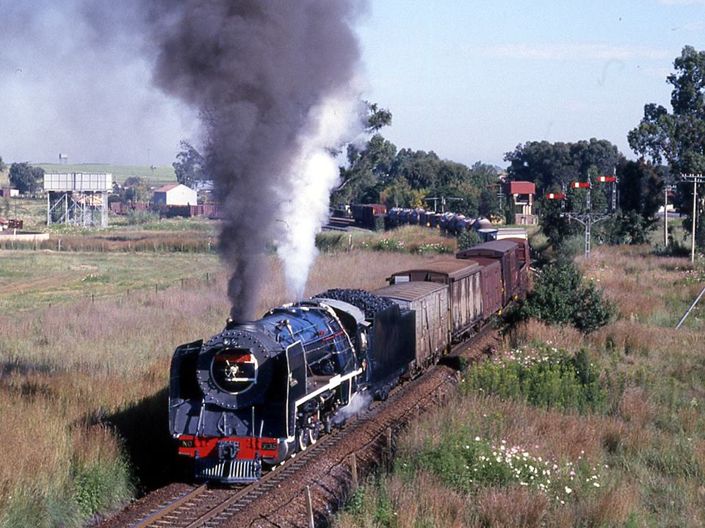
The original engines were hand fired but later batches were fitted with mechanical stokers and some acquired larger tenders from withdrawn Class 23 locomotives. The 15F’s were very much go anywhere, do anything engines and could be seen on every type of duty from express passenger to heavy freight, and most major depots had an allocation. The last of the class ended their SAR days on shunting and trip work at Germiston depot in Johannesburg. Phil Braithwaite’s superb photograph above shows Springs shed’s Prestige 15F No 3135 (NB 26019) with a freight train on the line to Bethal in 1986. Two Free State 15F’s are shown below, No 3130 (NB 26014) at Bloemfontein and 3109 (NB 25993) passing Bethlehem Box in November 1987.
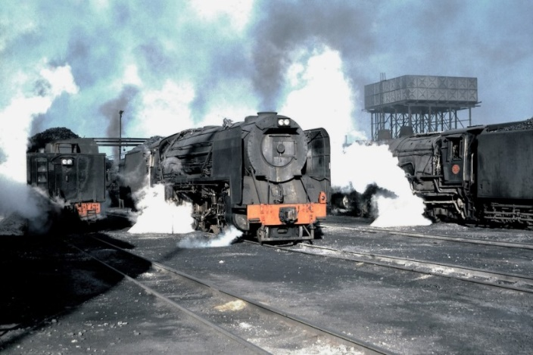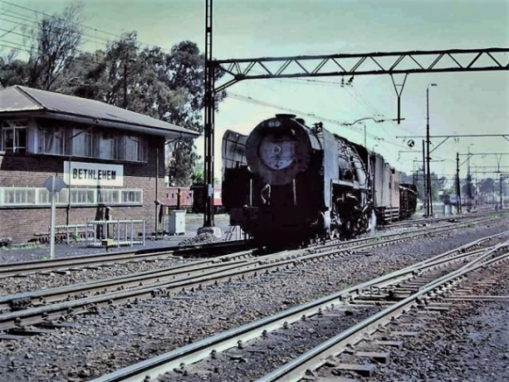
A small number of the Class remained in active service until the 1990’s and several have been preserved, including No 3007 (NB 25546) which was shipped back to its home city of Glasgow in 2007 and can now be seen in the Glasgow Riverside Museum. An excellent article giving full details of the 15F’s can be found at :
https://en.wikipedia.org/wiki/South_African_Class_15F_4-8-2
(5)
NEWS IN BRIEF (photo courtesy Tony Marsden)

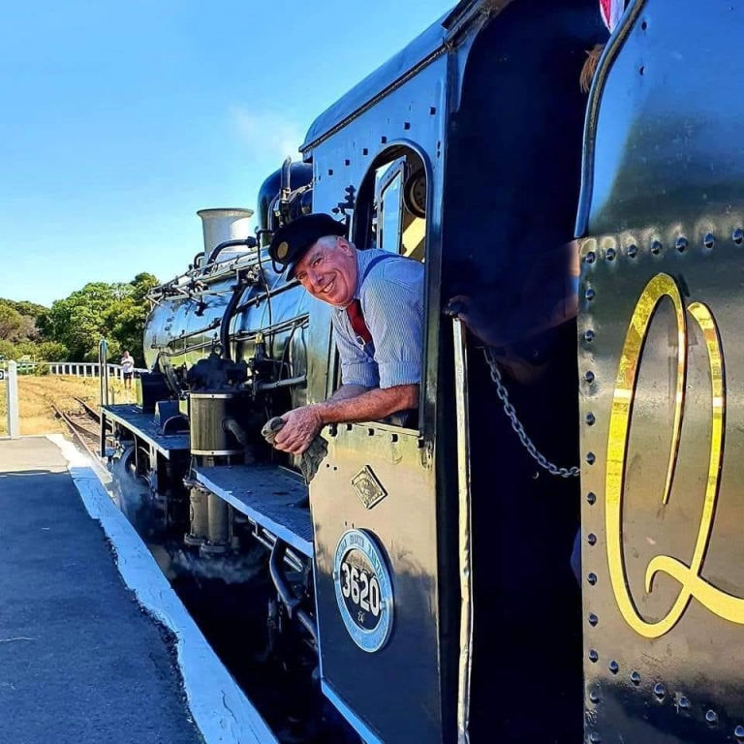

It is with great sadness that we have to record the passing of Michael Barclay in Australia on 10th July aged just 61. Michael had great plans for steam and headed the MeMyson and Wonder Steam operations. He is reported to have purchased three North British 15F’s and two 15CA’s from Millsite depot and most recently was co-founder of the Q Train Diner Service that was running with Class 24 3620 in Australia. Our thoughts are with his family at this sad time.
The overhaul of 19D 2767 at Hermanstad has been delayed as MRC and the repairers have not been able to agree the cost of the additional boiler repairs that were outlined in our May Newsletter. MRC are currently looking for an alternative supplier to carry out the boiler work. This loco is of course owned by a consortium of NBL Preservation Group Members. Hopefully this issue can be resolved soon but we are unsure what impact the sad news above will have on the project. In the meantime, MRC are moving forward with the creation of a Museum at Middelburg and have restored electric power to the station after a 10 years absence.
LNER design B1 No 61306 (NB 26207) has been very busy lately running frequent day trips from London Victoria to Windsor plus evening work on the Sunset Steam Express from Victoria to Chertsey and back. On top of this there have been longer trips on the main line including a Father’s Day Special from Portsmouth to Brockenhurst and back and a trip from Southend to Eastbourne and Hastings. Full details of the B1’s, and many other, forthcoming tours can be found on the Steam Dreams website : https://www.steamdreams.co.uk
If you would like to comment on any of the items in this Newsletter or discuss any of the issues raised above please email ken.livermore@btinternet.com or phone me on 07990 575 103. Photos and news items for future Newsletters are always needed and can be emailed to me or posted on our Facebook page at : https://www.facebook.com/NorthBritishLocomotives

Thank you all once again for your continued support, stay safe out there !
More news to follow next month, Best Regards, Ken

Newsletter published by the NBL Preservation Group - A Not for Profit Organisation

