NBL Preservation Group

Honorary President Professor Dugald Cameron OBE

October 2021 Newsletter

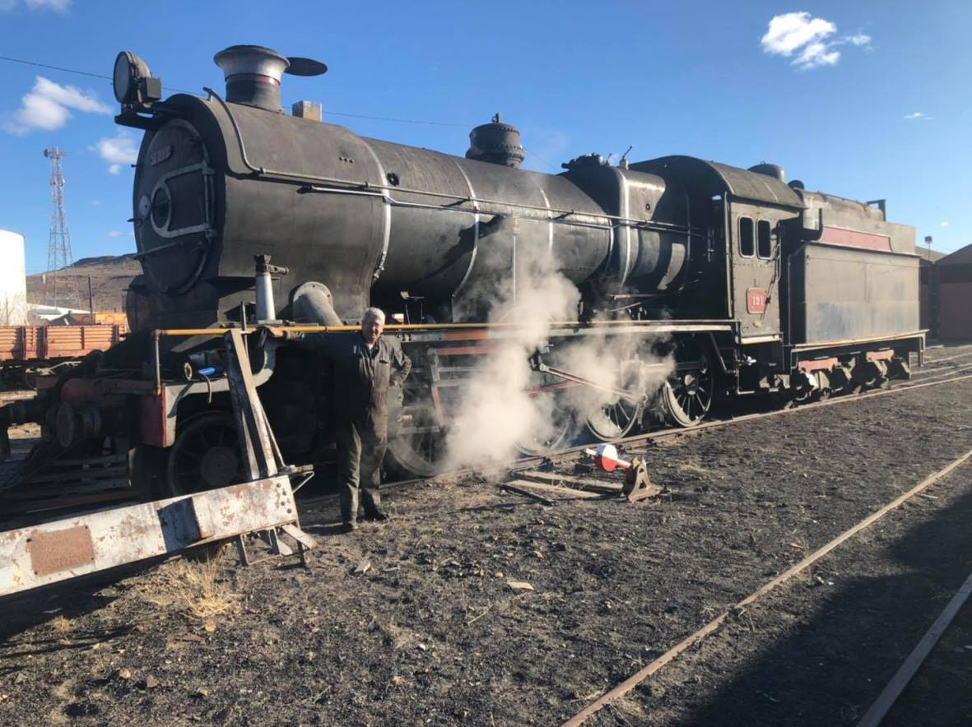

STEAM IN ARGENTINA Photo courtesy GyG Metalmecanica

Great news from Argentina is that former Buenos Aires & Pacific 2-8-0 No 121 (NB 19778) was steamed on 19th September and has moved under its own power once again. There is further work to be carried out on the engine but it is hoped that it will return to revenue earning service in due course.

No 121 is one of 14 of this type built for BAP by NBL at their Queens Park Works in 1911 and was most recently used on tourist trains in the south of Argentina in the 1990’s. Prior to its restoration, it is thought to have been stored in the shed at Ingeniero Jacobacci for at least a decade. We are very grateful to Martin Coombes and Trevor Heath for bringing the news on this locomotive to our attention and more information about the project can be found at : https://www.facebook.com/maquinasavapordegyg

It is not all good news this month I’m afraid, as just as the worldwide steam movement starts to recover from the pandemic, we have further reports of theft in South Africa and the possible privatisation of the Hill Railways in India. Please read on for further news.

(2)
SANDSTONE MOVES (Contd) (main photo : Andre Guelpa)
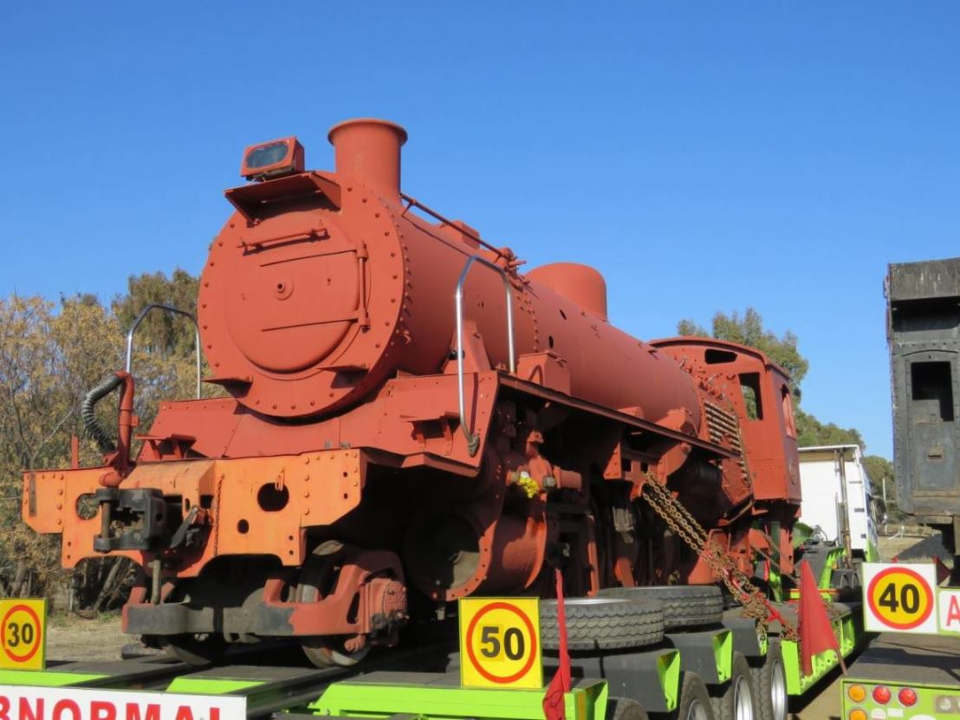
The exodus of Sandstone’s Cape Gauge steam locomotives from Bloemfontein continues with North British 24 Class 2-8-4 No 3688 (NB 26400) the latest engine to be collected. Once these moves have been completed, we understand that attention will turn to the mothballed steam shed at Germiston where Sandstone’s collection includes a North British 25NC No 3488 (NB 27348) and the former David Shepherd 15F No 3052 (NB 25591). No 3052 was the loco involved in the spectacular derailment on a railtour near Cullinan a few years back when it was discovered too late that scrap metal thieves had stolen several lengths of rail and the train could not be stopped in time! The collection will be much more secure at Sandstone and it is hoped that the engines can be placed on display in the longer term. Nos 3052 & 3488 are seen at Germiston in 2018. (KL Collection)
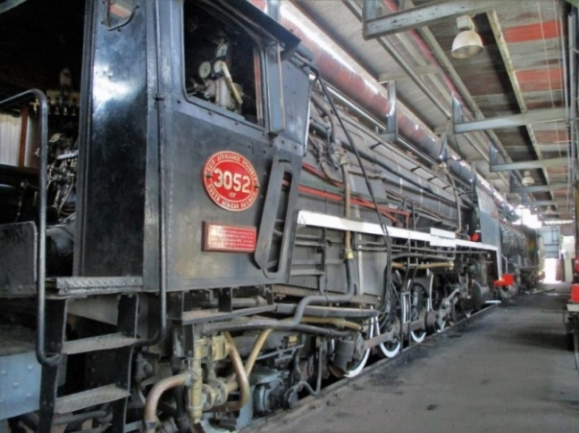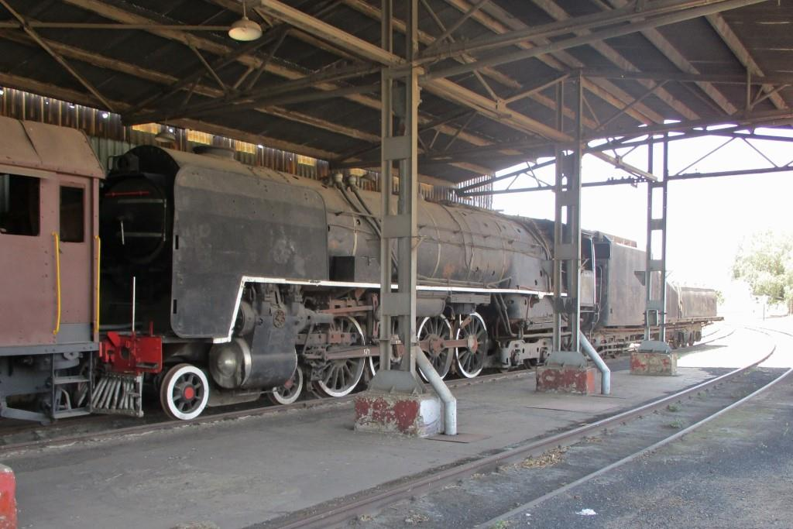
Security has become a major issue on South Africa’s railways in recent years with many stations having been vandalised and even the tracks and overhead wires stolen in some cases. Stored steam locomotives have been stripped of valuable parts and the dreadful incident at Chamdor is still fresh in the memory when a number of preserved engines had to be scrapped after being attacked by metal thieves. Even the Outeniqua Transport Museum at George has not been immune to theft and we have recently received a report of an incident at the Wonder Steam premises in Pretoria where RSH 19D No 2767 is currently based. This loco is under overhaul for the Mpumalanga Rail Company but is of course owned by a consortium of NBLPG Members. The local police have been asked to investigate and we will keep you informed as soon as we hear more.
(3)

DARJEELING CHANGES (photos courtesy Bob Francis)

India’s government has unveiled a wide-ranging National Monetisation Plan to ‘monetise’ (with private sector participation) the infrastructure assets of its highways, power supply and railways sectors. The plan, which is due to be completed by 2025, encompasses some 400 stations, 265 railway goods sheds and four narrow gauge Hill Railways, including the Darjeeling Himalayan Railway with its NBL and Sharp Stewart steam locos.

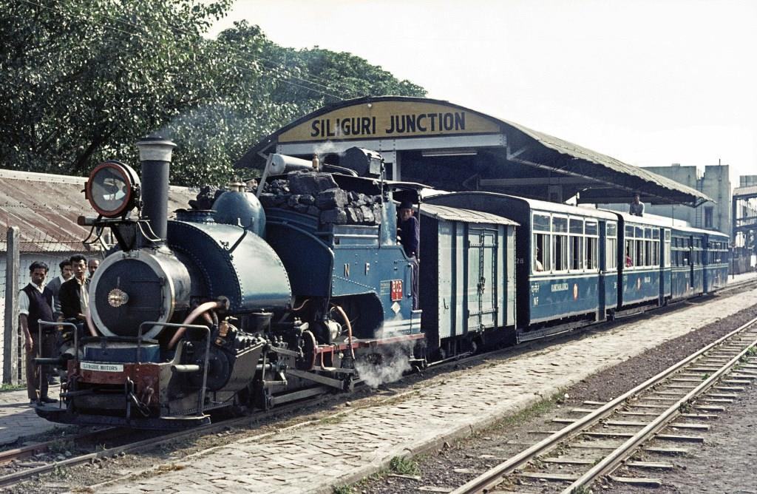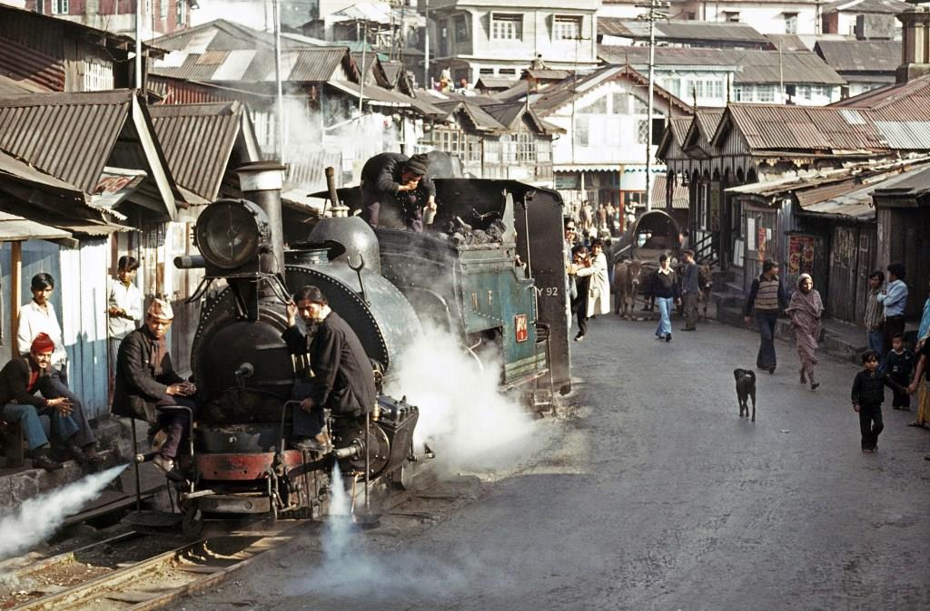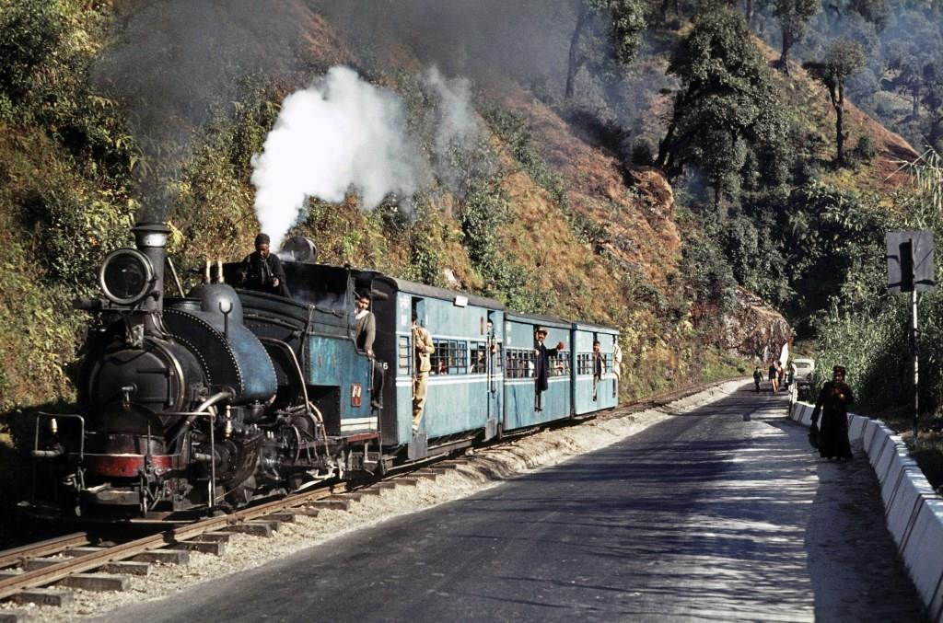

The Darjeeling Himalayan Railway Society are aware of these plans and are awaiting the precise proposals. They are keen to bring their long and deep involvement with the DHR to bear as the specific proposals are developed. Indian Railways are fully aware of their wish to be part of the dialogue with other key stakeholders, such as Indian Tourism and local organisations which will determine the future of the DHR. The DHRS have put out a comprehensive Press Release covering current operations and the travel situation and this can be found on their website at : http://www.dhrs.org.uk/DHRS%20press%20release30082021.pdf

In the meantime, timeless scenes like these photographed by Bob in 1975 are available for all to enjoy.
Top No 803 NBL 20642/14 at Siliguri Junction 19/11/75. This was a TEFS charter, which followed the service train to Darjeeling. On this day the service train ran in 3 sections. Our stock included a luggage van and 3 First Class carriages, including the Observation Car Kanchenjunga.
Left No 780 SS 3883/92 at Kurseong 20/11/75 with a portion of the through train from New Jalpaiguri to Darjeeling, coming through the Bazaar. Notice the “Coal Breaker Man” on the bunker rinsing the smuts from his eyes with a can of water, and also the bullock cart in the right background being loaded/unloaded.
Right No 787 NBL 20143/13 21/11/75 en route to Darjeeling with the 07.05 ex Kurseong, usually referred to as the “School Train”. Many thanks to Bob for these superb photos.
(4)
NEW ZEALAND STEAM (photos : JM Creber)

Our good friend Wilson Lythgoe has been digging into his files again this month and has come up with two more North British gems from the JM Creber collection. Many thanks Wilson, for these wonderful views.

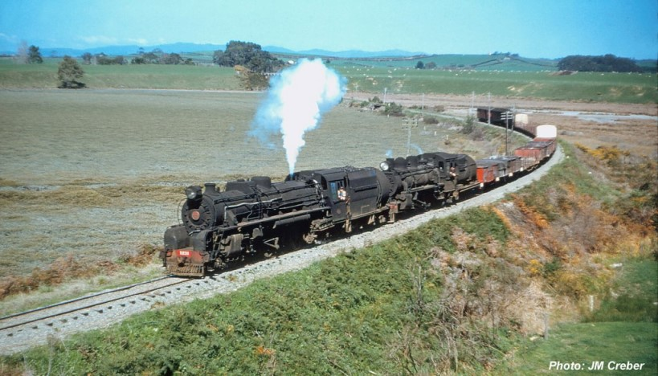
J Class 4-8-2 J1231 (NB 24554) & Ab pacific No 701 are seen approaching Omokoroa on the East Coast Main Trunk, with 328 Mixed on 25 September 1957. Mixed in this instance means a goods train with passenger carriage attached, it can be seen at the end of the train, just in front of the guard’s van.

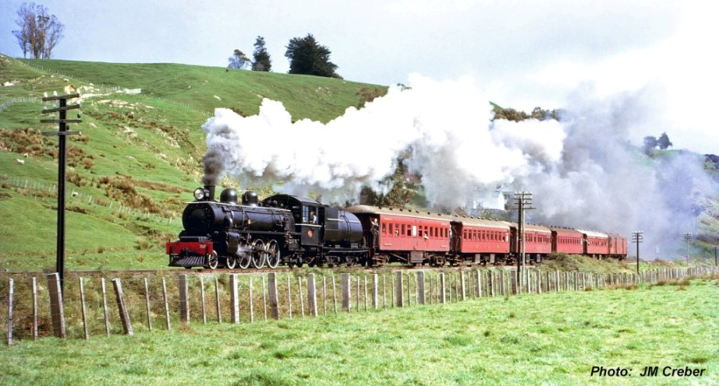
On 15th September 1962 an excursion to Taihape was run by the Wellington Branch of the New Zealand Railway & Locomotive Society. From Paekakariki Abs were used - 819 between Paekak and Palmerston North and then 758 up to Taihape The train is seen near Hunterville hauled by Ab 4-6-2 No 758 (NB 23175).

(5)
NEWS IN BRIEF (photo : KL Collection)
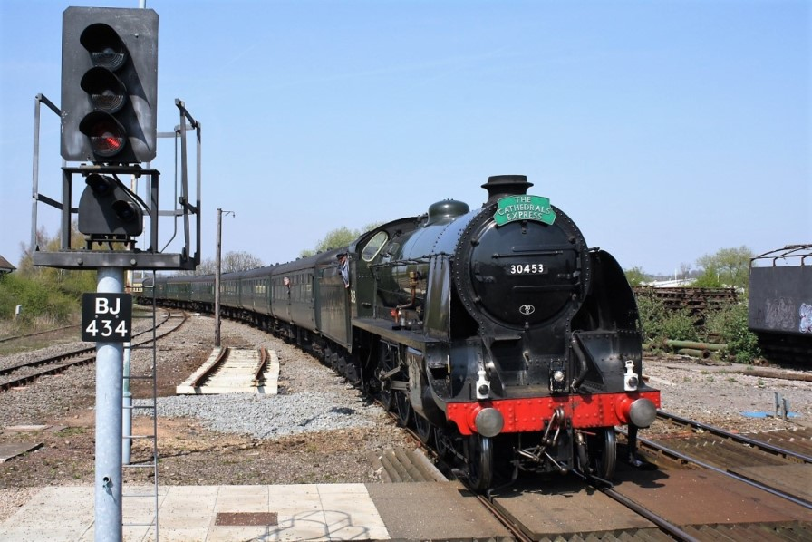
Ex-Southern Railway ‘King Arthur’ Class 4-6-0 No. 30777 ‘Sir Lamiel’ (NB 23223) is set to return main line running thanks to a new agreement between the National Railway Museum and the 5305 Locomotive Association. The overhaul of No 30777, which is part of the National Collection, is taking place at Loughborough depot on the Great Central Railway and is expected to be completed in 2023. Once ‘Sir Lamiel’ is back in steam it will make appearances on the main line and at other heritage railways in the UK. The loco is seen above entering Stratford on Avon in the guise of class leader ‘King Arthur’ in April 2010.
The B17 Trust, who are building a replica North British design LNER ‘Sandringham’ locomotive, have launched a £70,000 appeal to raise funds for the deposit on a new-build boiler. In the meantime, the coupled axlebox casting have been completed ready for final inspection. The patterns for the wheel castings are also being checked prior to the order being raised. More details on : https://www.b17steamloco.co.uk
Quite amazingly, 10 years have now passed since the former Duke of Sutherland’s locomotive ‘Dunrobin’ (Sharp Stewart 4085) was returned to the UK for restoration. Beamish Transport Museum have put out a report on their website detailing the delays and the spiralling costs for the project which they now estimate will have reached £500,000 by the time the engine is returned to traffic in 2024. In the meantime, the overhaul continues at Bridgnorth Workshops on the Severn Valley Railway. Full details can be found on the Beamish website at : http://beamishtransportonline.co.uk/2021/05/dunrobin-ten-years-on
If you would like to comment on any of the items in this Newsletter or discuss any of the issues raised above please email ken.livermore@btinternet.com or phone me on 07990 575 103. Photos and news items for future Newsletters are always needed and can be emailed to me or posted on our Facebook page at : https://www.facebook.com/NorthBritishLocomotives

Thank you all once again for your continued support, stay safe out there !
More news to follow next month, Best Regards, Ken

Newsletter published by the NBL Preservation Group - A Not for Profit Organisation

