NBL Preservation Group

Honorary President Professor Dugald Cameron OBE

November 2021 Newsletter

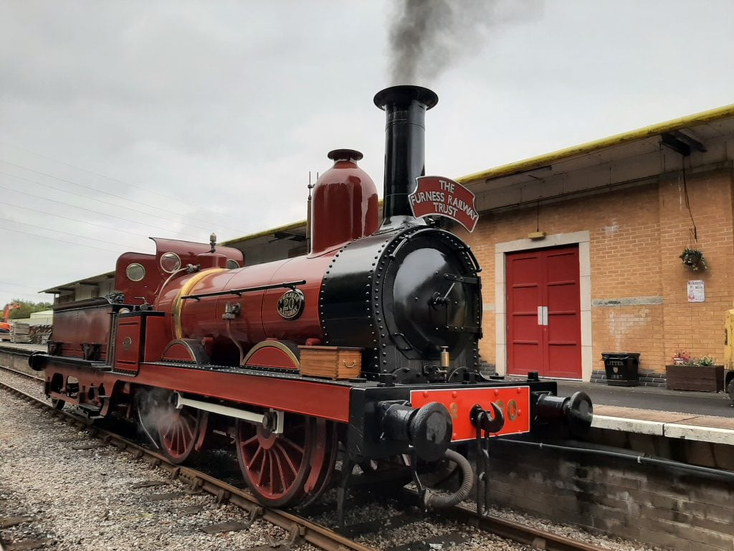

FR 20 STEAMED Photo courtesy Furness Railway Trust

Britain’s oldest working standard gauge steam locomotive, Furness Railway 0-4-0 No 20 (Sharp Stewart, Works No 1448) returned to steam in October 2021 after a thorough overhaul. No 20 was one of eight 0-4-0’s built for the Furness Railway in 1863 by Sharp Stewart & Co who were then still based in Manchester, prior to their move to Glasgow. After being sold out of service to the Barrow Haematite Steel Co in 1870, it was converted into an 0-4-0 Saddle Tank and worked at Barrow Steelworks for an incredible 90 years !

On withdrawal it spent a further 20 years on static display in the grounds of a school before being rebuilt back to its’ original form during 1996/98. After its’ third overhaul in preservation, this amazing survivor can now be seen in action at the Ribble Steam Railway near Preston. Full details of No 20’s history can be found at :
http://www.furnessrailwaytrust.org.uk/fr20story.htm
(2)
ARGENTINE RESTORATION (photos : John Turnock)
Following our news item about the restoration of 2-8-0 No 121 (NB 19778) last month, John Turnock has kindly emailed a selection of wonderful photos that he took during a trip with this locomotive 15 years ago on 25th November 2006. John was taking part in a railway tour of Chile and Argentina organised by the RTC (Railway Touring Company) and this was a private excursion for RTC customers – which included a good number of photostops and run-pasts.

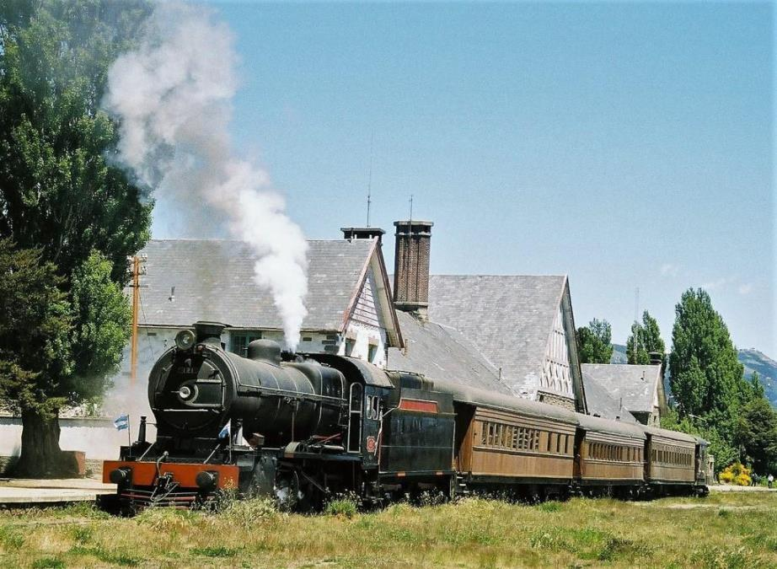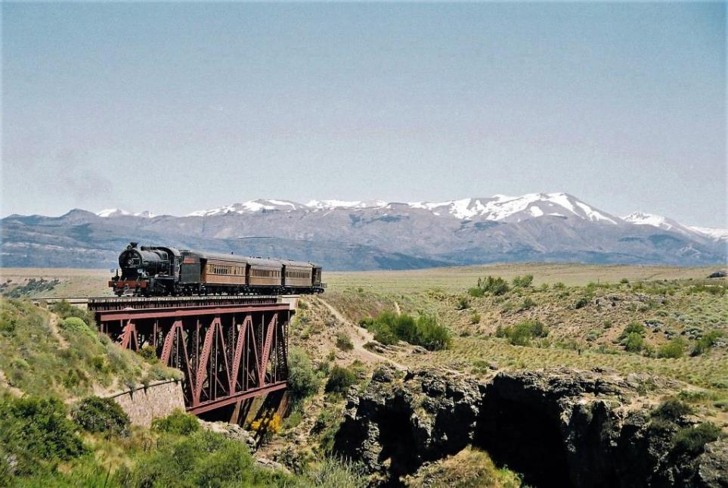
The trip ran from Bariloche (above) which was the base of No. 121 at the time, through some spectacular scenery, to Perito Moreno station, sometimes known as Los Juncos. This is some 40kms east of Bariloche.

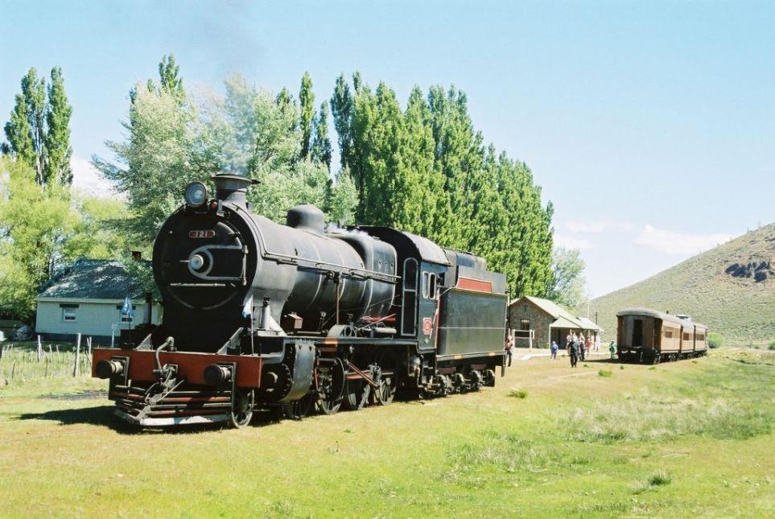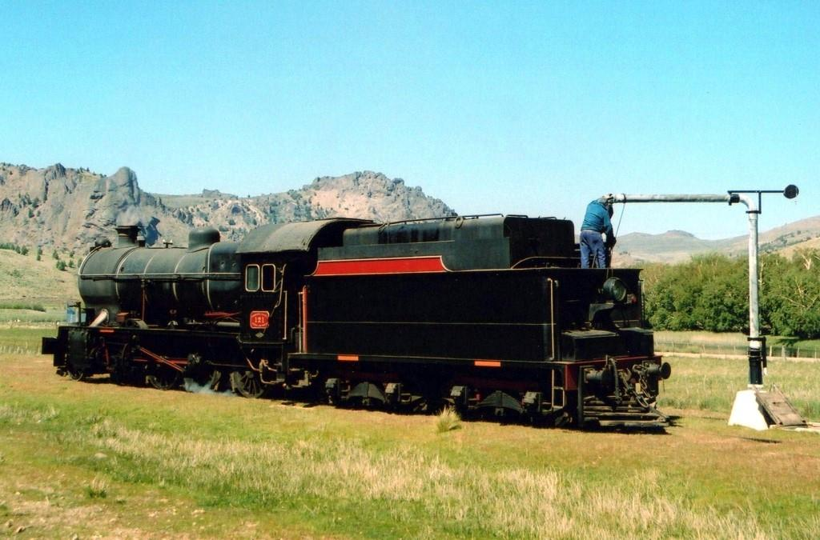
Refreshments were available at Perito Moreno, where the loco was turned on a triangle and took water. Perito Moreno lies in the Department of Pilcaniyeu in the province of Rio Negro.

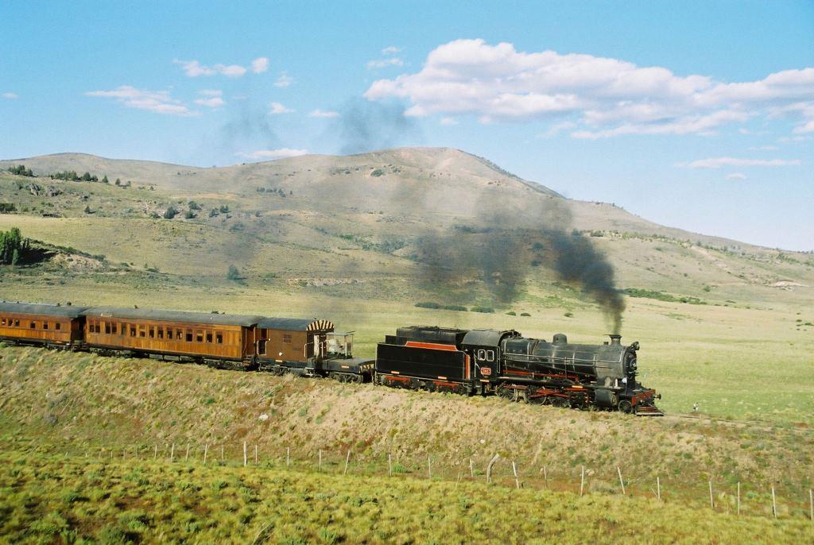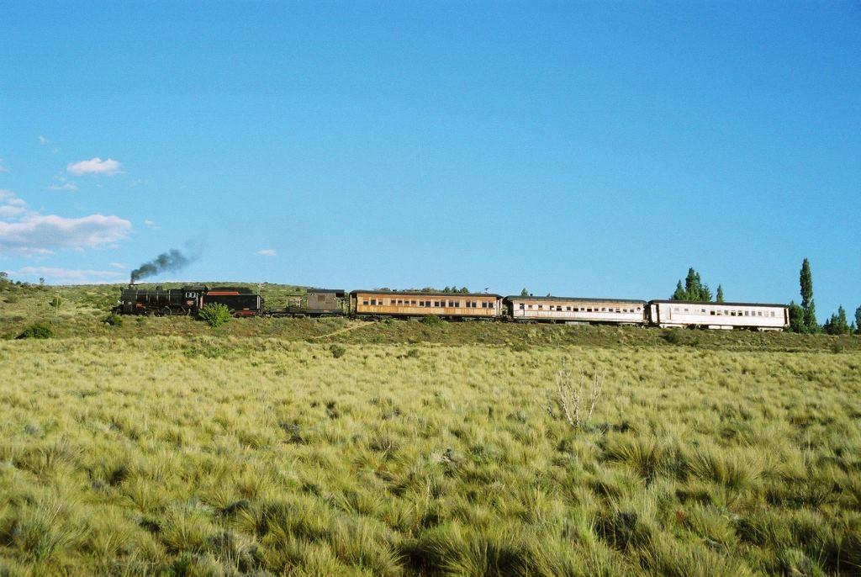
Perito Moreno is not served by normal passenger trains, but Pilcaniyeu to the east is. Beyond Pilcaniyeu is the junction station with the narrow gauge "La Trochita" at Ingeniero Jacobacci where No 121 was recently restored. John’s final photos show the train on the return run, let’s hope that these scenes can now be re-created. Thanks again to John for a great selection of photographs.
(3)
SA SHAME (notes & photo Sandy Buchanan)
One of our SA Correspondents, Sandy Buchanan visited Springs Station on 14th October and has emailed us to highlight the sad plight of a North British steam loco that was once the pride of the line. Sadly, this has become the fate of many plinthed locos up and down the country.

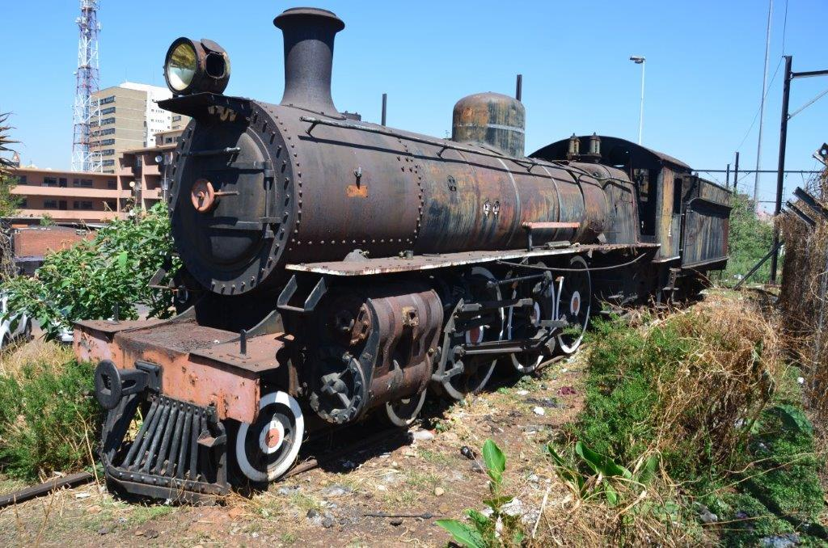
Standing in squalid conditions at Springs station, in poor condition, is once proud former Central South African Railways (CSAR) class 10 locomotive number 662, the third last loco of this order, built by the North British Locomotive Company in 1904. (NB 16228)
The CSAR took over the Imperial Military Railways (IMR) operations and rolling stock at the end of the second Anglo-Boer War 31 May 1902. The CSAR in 1910 was absorbed into the newly established South African Railways (SAR) in 1910 with the formation of the Union of South Africa. The CSAR, despite its short life of only eight years, was a progressive organisation and had competent staff, notably its first Chief Locomotive Superintendent, P A Hyde. There is little in writing about this company or the man.
Upon the formation of the CSAR, many of the locomotives inherited from the IMR were either very old, damaged from the war, or unable to handle the growing traffic loads economically. Hyde set to work immediately in modifying some of the locos, but more importantly, designing new classes which were ahead of anything else in the country at the time. This was applicable not only to locomotives, but carriages as well.
By 1904 Hyde had designed and placed in service the following –
1) A new 4-6-4 tank loco for suburban traffic - the class F tanks. Handsome engines they were named "chocolate boxes" by the running staff. Vulcan Foundry built 8 of them.
2) Another new loco class for passenger traffic - the class 9. A Pacific with 4ft 9inch diameter driving wheels. For South Africa at the time quite a bold step. Five locos were built by Vulcan Foundry.
3) Then came his Class 10 Pacifics, including No 662 at Springs. These express passenger locos were built by North British. Walschaerts valve gear, Belpaire boilers and 5ft 2 inch diameter drivers! The locos all up weight
including tender was just over 121 tons. They were ahead of anything else in the country at that time, with the possible exception of the Cape Government Railways class 5 locos. Fifteen were built with saturated steam, but later orders commencing with the class 10B were superheated. Renumbered under the SAR they became numbers 732 - 746. The pictured loco became SAR No 744.
This wonderful locomotive, in working order, was plinthed many years ago at a formal ceremony at Springs Station. Since then and particularly in the last 25/30 years all brass fittings, sight glasses and the like have been stripped from the loco. So sad to see! It should be moved to a secure location. Ideally it should be restored to full working order. This loco epitomises the wonderful steam engine heritage that South Africa once possessed. Sic transit gloria!
Sincerely, Sandy Buchanan. Thanks Sandy, for this very sad tale, let’s hope something can be done. Ed.
(4)
VISIT TO GREECE (notes & photo from Rabbi Dr Walter Rothschild)

We have up to date news on the surviving North British WD 2-10-0’s in Greece this month from one of our old contacts and from a new correspondent, Dr Walter Rothschild who has recently returned from a visit. Very useful information for anyone contemplating visiting the area. Walter takes up the story from here :

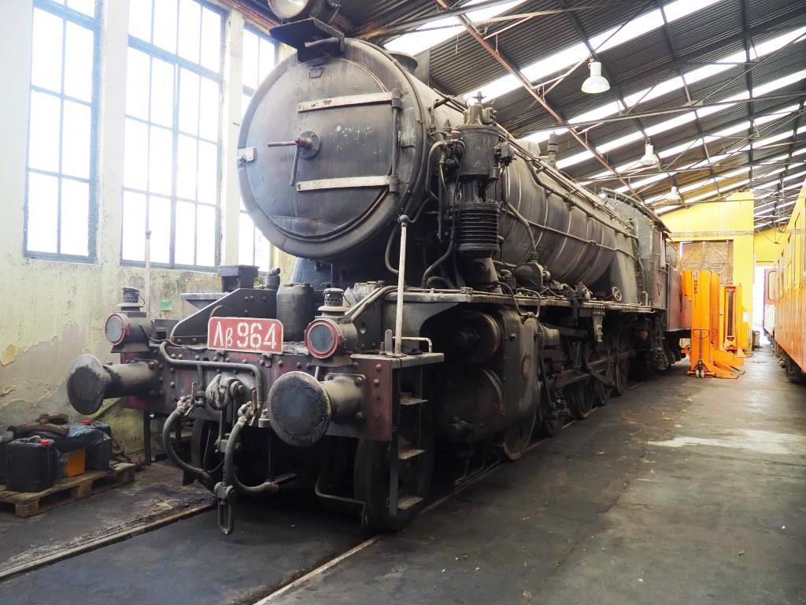

Recently I was invited to do a Reading at Thessaloniki. I am glad to say that the visit was a great success from this respect (though I was unable to travel there by train or to ride any trains having got there...) I am a complete beginner in terms of Greek railways and locos but I was able to arrange a guided visit to the Diesel Locomotive Depot (the electric loco depot is nearby) and confirmed that WD 2-10-0 No. 964 (NB 25468) stands in the shed here, complete and intact and being looked after. My guide told me that No. 962 (NB 25463) is stored at Drama, to the East. Outside the shed stood a USATC tank minus side tanks but coupled to (not connected to) an ancient 6-wheel tender. A lot of the Krupp-built German V60 type 0-6-0D's were standing here, semi-derelict, but one was acting as station pilot.
Walking eastwards, i.e. towards the terminus one comes to a row of trees and bushes. Hidden inside this and very hard to photograph were: An Austrian-type 0-10-0 plus tender; I have learned from Keith Chester who saw it in 1973 in much more presentable condition that this was 116.817. It looked intact, very rusty and the right-hand cylinder cover seemed blown; A USATC 0-6-0T; An S160 USATC (Theta Gamma) 2-8-0; A Greek 2-10-0 with four-axle rigid wheelbase tender; Two more USATC 0-6-0T's. All are rusty and unidentifiable now, but seem largely intact.
We then drove to the site of the planned Holocaust Museum; this is at the western extremity of the complex of tracks and sidings forming the Old Station (CO) now used as a freight station. Here stands a S160 Theta Gamma 520 with four wooden goods vans - clearly this can only be symbolic of deportation trains, it is not historically authentic. The former Old Station (CO) itself several hundred metres away has a siding with five covered vans - all of postwar design - also acting as a memorial to the deportation of the 50,000 Thessaloniki Jews to Poland in nineteen transports in 1943/4 - hardly any survived.
Nearby, half hidden behind scrap rolling stock and also in trees - I was told these had been cut back in springtime but had grown back since - were three more S160s and an Ansaldo-Breda 2-10-2. Nearby is also a stone shed, most of the eight tracks disconnected and the roof leaking, but kept safely inside is S160 Theta Gamma 525. (Walter’s report continues on page 5)
(5)
VISIT TO GREECE (Contd)
The Thessaloniki Railway Museum is situated in the open air between the main line and the main Nea Monastirou road (accessible by 54 bus from the station, or a taxi is only about €7). It is only open two mornings a week and has a very heterogenous collection including a de Glehn 4-6-0, alas missing its centre driving axle and tender but still beautiful, a diesel shunter, two Wagons Lits carriages, several ancient goods vehicles and a large collection of draisines; But it also has two more USATC 0-6-0T's, one with an extended bunker. Also, a bit of 60cm gauge track and several Decauville wagons. An electric loco hauled a train of containers (mostly Chinese) out of the freight yard along the main line while I was there. One exhibit is a 1942-built Wehrmacht mobile kitchen, left behind!
The main (new) railway station is concrete and painted white and has seven terminal platforms. Two-car blue-painted dmus worked in and out and the 120 class electric Bo-Bos on trains of four coaches - amazingly graffitied at least until window height though the solebars remain clear and legible. There was NO information as to departures or arrivals! A Metro to link the station with the eastern end of town has been under construction for many years and is already heavily delayed and over budget - I was told that work stops every time a new archaeological discovery is made. I was also told that for publicity purposes one station was ceremonially opened even though nobody can yet use it.
Outside the Jewish Museum on Mina St. is a section of original metre-gauge tram track - the system closed 1957 and the tracks were rediscovered by accident during road works and were then revealed fully. Inside the museum is the grave stone of a Jewish tram driver with the image of a tram carved on it!
We are very grateful to Walter for this comprehensive report on Thessaloniki. Co-incidentally, our old friend Apostolos Anastasiadis has sent us this photo of WD No 958 (NB 25445) which is dumped at Tithorea depot. It seems that there is also a possibility that WD 955 (NB 25442) may still exist somewhere in Thessaloniki. The dumped loco’s days would appear to be numbered so it would be best to check before travelling !
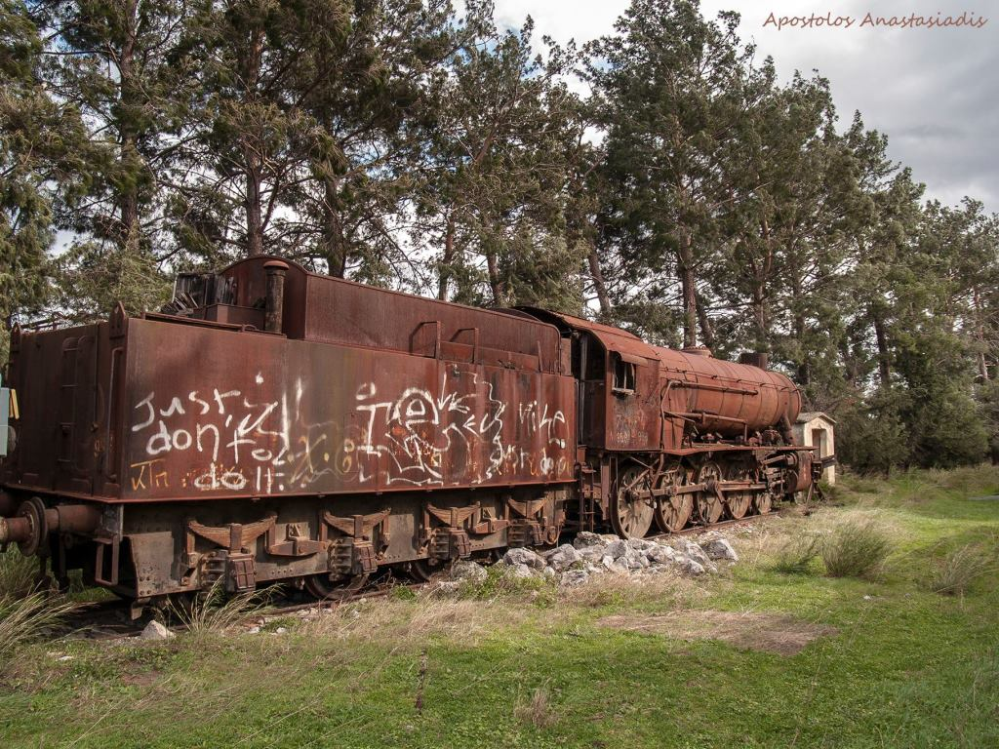
Before we leave the subject of NBL WD 2-10-0’s, Number 90775 (NB 25438) formerly Lb 951 in Greece and now on the North Norfolk Railway, was re-named ‘Earl Haig’ at a ceremony on 26th September to mark 100 years of the British Legion. It had been named ‘The Royal Norfolk Regiment’ in September 2017.
(6)
NEWS IN BRIEF (photo : Pauline Williams)
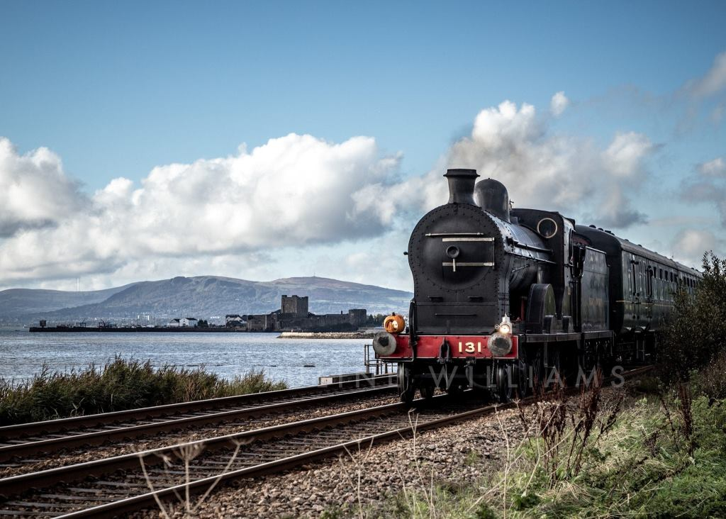
The Railway Preservation Society of Ireland ran their first public trains in nearly 2 years between Belfast and Whitehead over the Halloween Weekend of 30th / 31st October. The Sunday morning "Wizard's Express", hauled by GNR (I) 4-4-0 No 131 (Neilson Reid 5757) is seen near Downshire with the imposing backdrop of Carrickfergus Castle. Details of future RPSI events are at : https://www.steamtrainsireland.com
The Gresley Society have launched a £100,000 Appeal to complete the overhaul of their preserved N2 Class 0-6-2 Tank No 69523 (NB 22600). The high cost of a large number of items that needed to be replaced on the engine has left the Society with a funding shortfall. These include the pony truck tyres, smokebox and firebox tubeplates, crankpins and safety valves. In addition, the firebox wrapper has been found to need replacement due to cracking around the crown stay holes. Full details can be found at : www.gresley.org
The Mpumalanga Rail Company have reported that the theft from SAR 19D No 2767 at Wonder Steam was only minor and that security patrols are being stepped up to make the site more secure. The break-in was reported to the Police and is now in the hands of the Hawks Special Investigation Unit. MRC have received their Access Agreement for Middelburg Station, No 2767’s eventual home, and a successful opening festival was held there from 15th – 17th October. https://www.facebook.com/MpumalangaRailCompany

If you would like to comment on any of the items in this Newsletter or discuss any of the issues raised above please email ken.livermore@btinternet.com or phone me on 07990 575 103. Photos and news items for future Newsletters are always needed and can be emailed to me or posted on our Facebook page at : https://www.facebook.com/NorthBritishLocomotives

Thank you all once again for your continued support, stay safe out there !
More news to follow next month, Best Regards, Ken

Newsletter published by the NBL Preservation Group - A Not for Profit Organisation

