The NBL Preservation Group

Would Like To Wish Everyone

A Merry Christmas !


.... 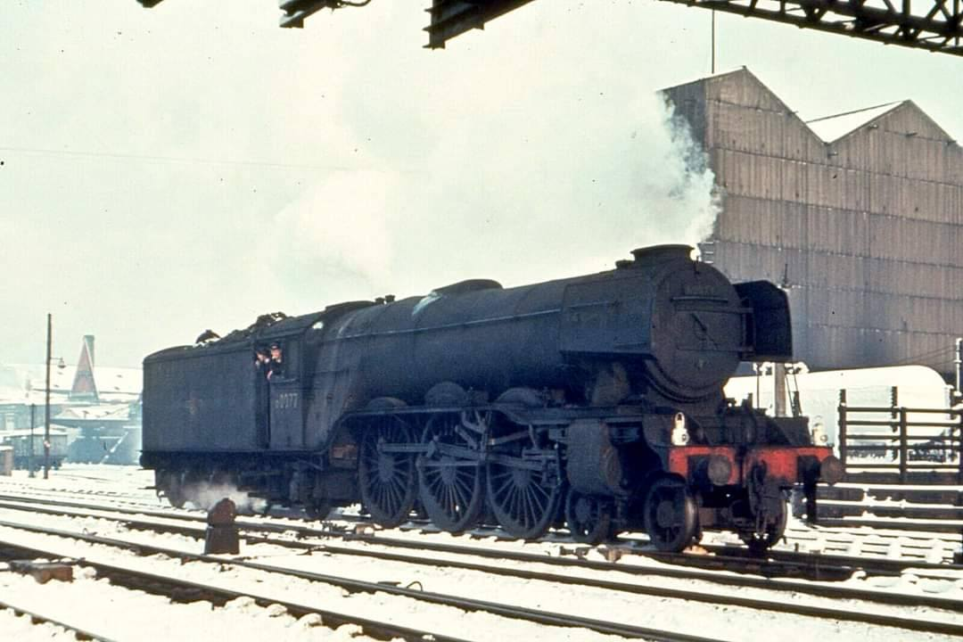

WINTER CHILL (from ‘Darlington as it Looked’ webpage)

You can almost feel the chill in the air as LNER A3 Pacific No 60077 ‘The White Knight’ (NB 23114) runs light into Darlington station during the bitterly cold winter of 1963. This engine was one of 20 of the class built by North British in 1924 and spent almost 40 years working crack express trains on the East Coast Main Line. Originally designated Class A1, they were all eventually rebuilt to Class A3 with improved superheaters, longer travel valves and left-hand drive.

Due mainly to the various lockdown and travel restrictions, progress with our own locomotive projects has been painfully slow during 2021 but we remain hopeful that the New Year will bring some improvement. I’d like to thank everyone for their continued support and interest during these challenging times and look forward to bringing you news of North British locomotives and preservation projects from around the World in 2022. Merry Christmas everyone, stay safe out there.
(2)

3620 BACK IN ACTION (photos Tony Marsden)

Whilst the UK heads into deep winter, Tony Marsden has kindly sent another set of photos of Class 24 3620 (NB 26332) which he has been driving in much sunnier weather in Australia. The loco has returned to active service after the most recent set of lockdown restrictions.

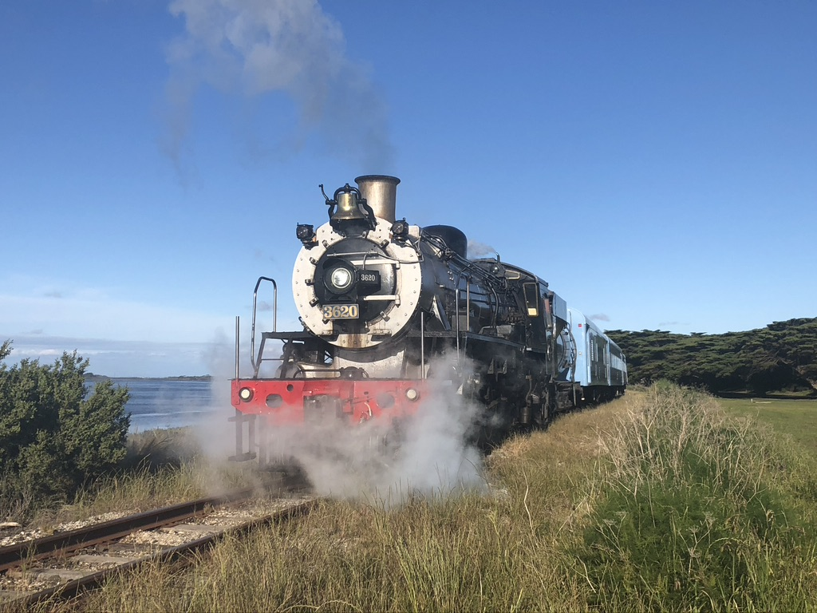
Hi Ken, I drove the evening Q train on November 20th and have attached some pix in two emails. The train runs from Queenscliff to Drysdale and return leaving at 6-30 PM which gives superb early evening light because of our daylight-saving time. The train pauses beside Swan Bay to give diners the ambience of the Bay in early evening light and another stop is made opposite a pine plantation near the former Marcus station at Big Tree Block post. [You would have thought the driver could have positioned the loco with rods down!!]

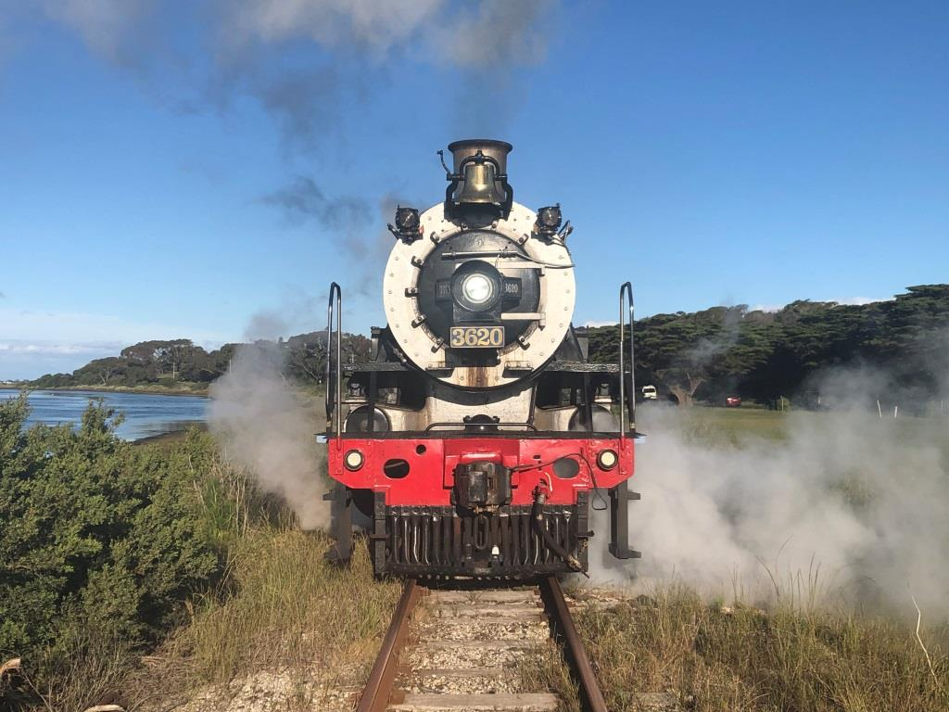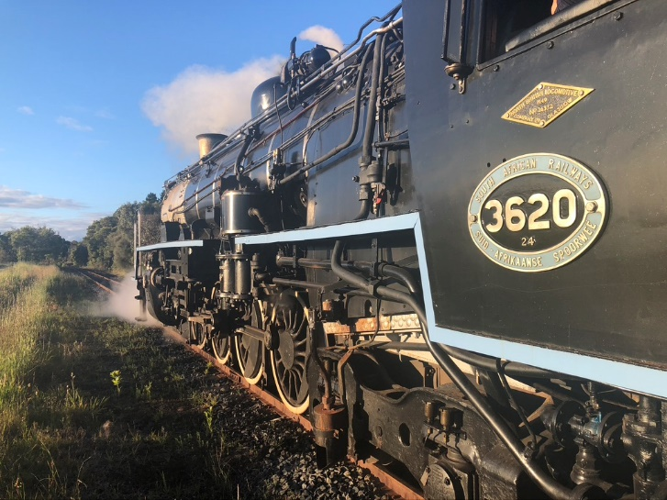

As can be seen in the third photo, No 3620 has now had a Westinghouse cross compound air compressor added
for the air braked stock. This was fitted for us at Cairns in Queensland. Hope these photos are of interest. Please wish all your readers a very Merry Christmas & a top 2022. Best Regards, Ashcat
- Cheers Ashcat, thanks once again for all your notes and photos. Ed
(3)
SPANISH MIKADO (Photos Richard Ricard)

We are very grateful to Richard Ricard for this wonderful selection of photos of RENFE 141F 2-8-2 No 2111 (NB 26975) which took part in various Centenary Celebrations in Spain in the 1970’s & 1980’s. No 2111 was one of 25 141F locomotives built by North British between 1951 & 1953.

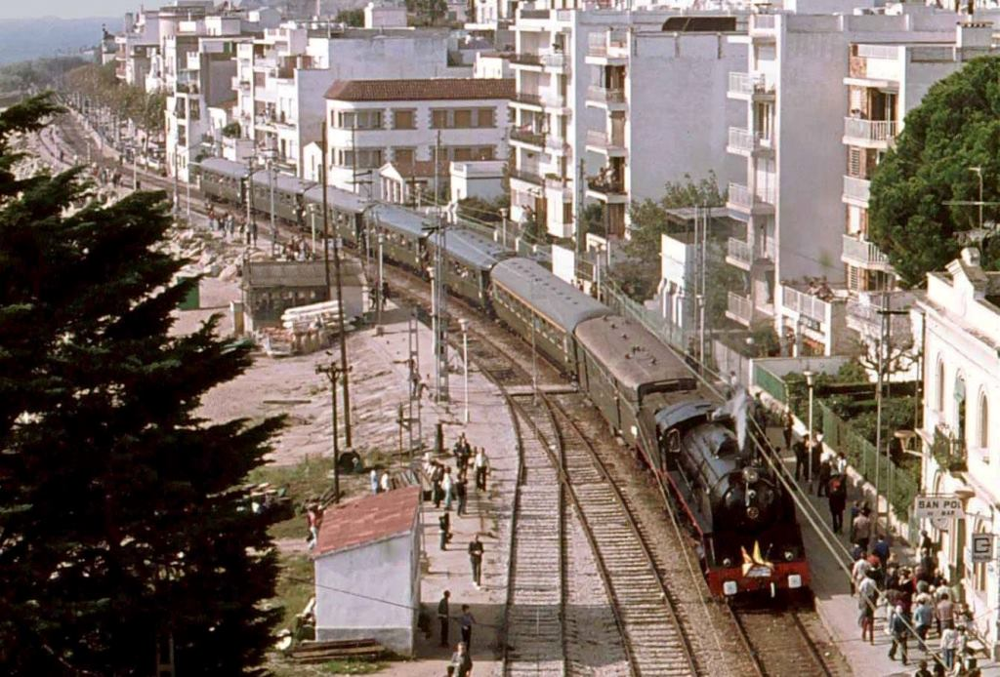

The engine can be seen above at San Pol de Mar and below at Reus, Tarragona, Mataro and Figueres respectively. It seems that Health & Safety programmes had yet to be implemented in the latter photo !

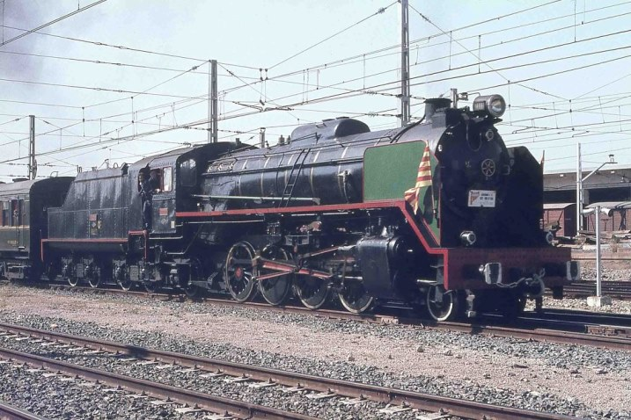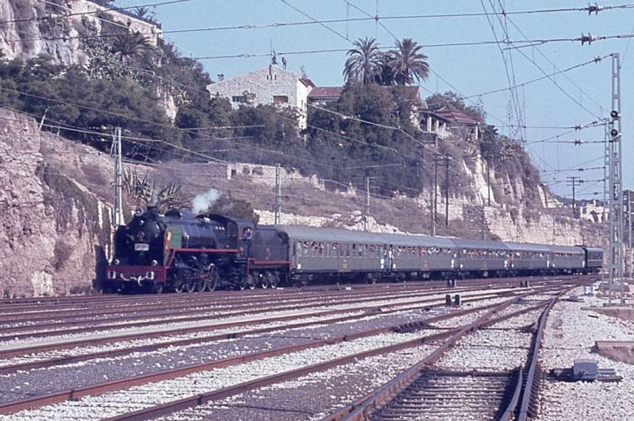

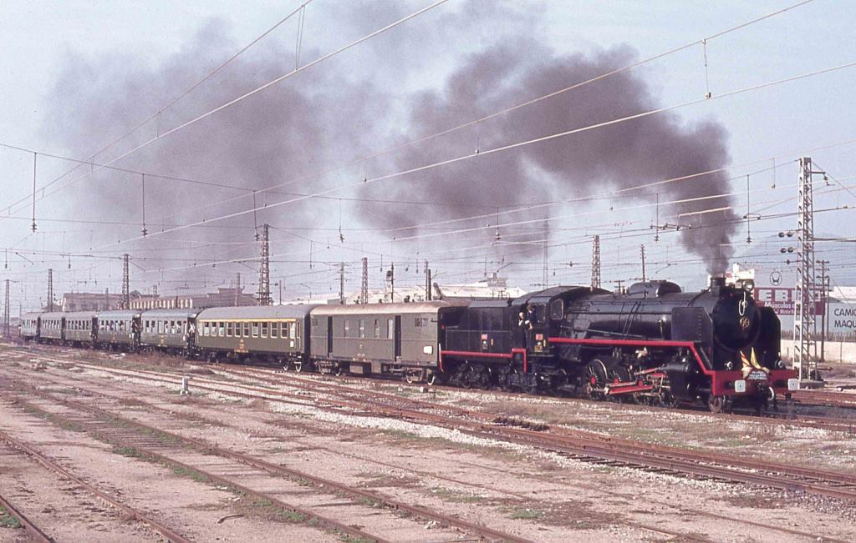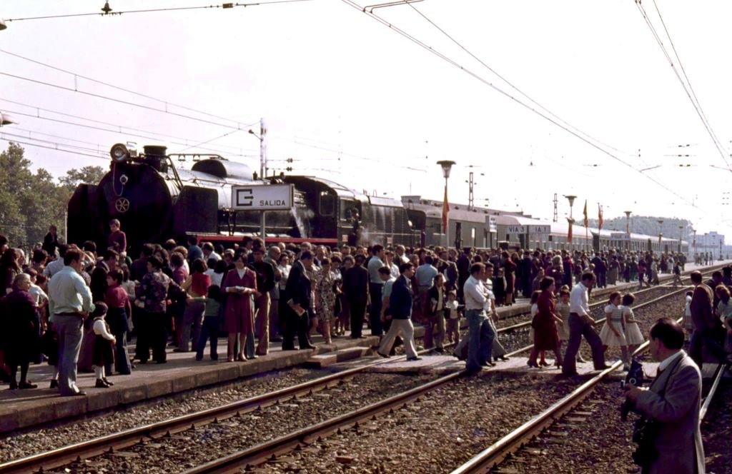

Fortunately this fine loco has been preserved and can now be seen in the Museo del Ferrocarril de Montforte. More of Richard’s photos can be found on Facebook at https://www.facebook.com/FerrocarrilesEspanoles
(4)
AUCTION ROUNDUP (Photos courtesy : www.gcra.co.uk )

December has come around again so it is time for our annual look at the Railwayana Auction scene. Like many other organisations, the Great Central Railwayana Auctions have gone on line with several smaller sales being held in place of the more usual mass gatherings at Stoneleigh. We have therefore scrolled back though the last few months sales to find NBL related items that went under the metaphorical hammer.

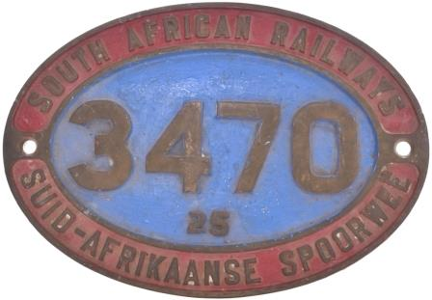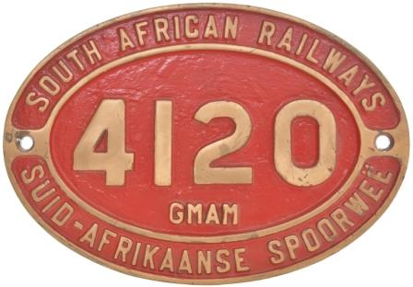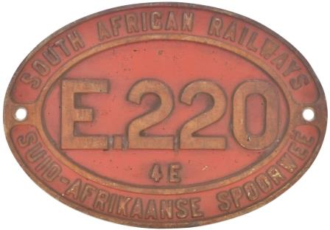

Cabside numberplate 3470 from a South African Railways 25 Class Condensing 4-8-4 (NB 27330) cast brass in ex loco condition : Sold for £900

Cabside numberplate, 4120, from a 3ft 6ins Gauge Class GMAM 4-8-2+2-8-4 Beyer Garratt built by the North British Locomotive Co, Works No 27778, in 1957 as sub-contractors for Beyer Peacock who also allocated their own Works No 7834. Cast brass, 20¾"x14½", the front cleaned and repainted : Sold for £820

Cabside numberplate E220 4E from a South African Railways Electric Locomotive (NB 26862) cast brass in ex loco condition : Sold for £290

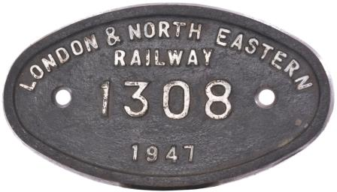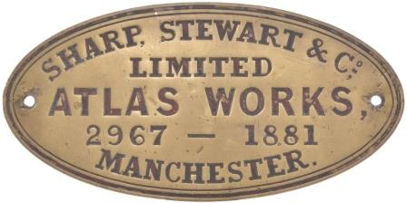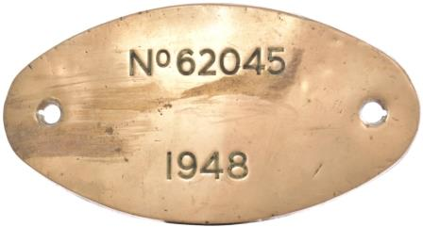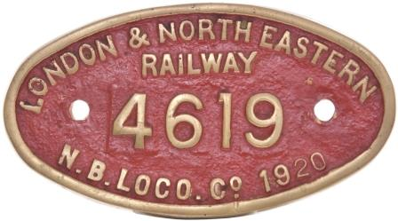

LNER 9 x 5 worksplate 1308 from a B1 4-6-0 (NB 26209) the front repainted : Sold for £120

Worksplate SHARP STEWART & Co LIMITED, ATLAS WORKS, MANCHESTER, 2967, 1881, from one of six 5'6" gauge 0-8-0s new to the Medina del Campo-Zamora-Orense-Vigo Rly, Engraved brass, 15½"x7½", unpolished : Sold for £2,700

LNER worksplate No 62045, 1948, from a Peppercorn K1 Class 2-6-0 built by the North British Locomotive Co, Works No 26649, in October 1949. it was withdrawn in September 1967 and sold for scrap to Hughes Bolckows Ltd at North Blyth. Engraved brass, 12"x6½", the front lightly polished : Sold for £320

LNER 9 x 5 worksplate, LONDON & NORTH EASTERN RAILWAY, 4619, N.B. LOCO Co, 1920, from a North British Railway Class B 0-6-0 No 109 built by the North British Locomotive Co, Works No 22672, at its Atlas Works, in December 1920. Cast brass, 9"x5", cleaned and the front repainted : Sold for £160

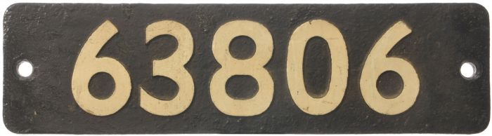

A smokebox numberplate, 63806, from a Robinson Great Central Railway type 2-8-0 built to Ministry of Munitions order by the North British Locomotive Co, Works No 21892, in May 1918 for the Railway Operating Division of the Royal Engineers, ROD No 1915. Withdrawn from Annesley on 21 November 1962, it was despatched for scrap to Derby Works in October 1963. The front repainted : Sold for £320
(5)
NEWS IN BRIEF (photo Bob Francis)

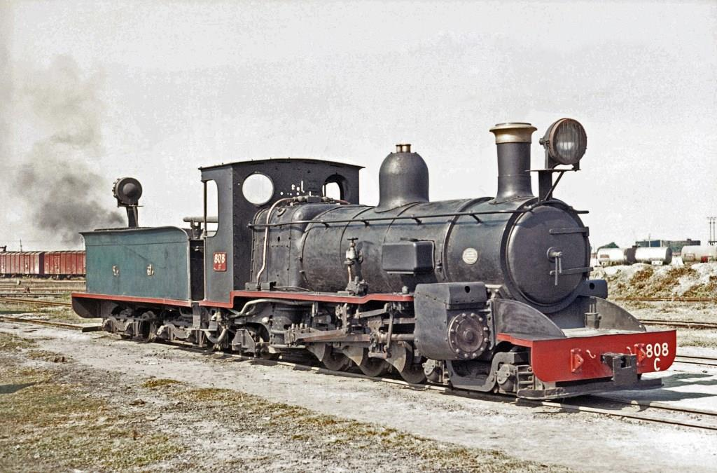

I’ve been saving this wonderful photo by Bob Francis for some time. It shows Darjeeling & Himalayan C Class Pacific No 808 (NB 20842) at New Jalpaiguri in November 1975. The DHLR had two of these beautiful little pacifics for the plains extension to Kishanganj but they were little used in later years after the closure of the branch, being totally unsuitable to the hill section. They were both withdrawn in 1969, but lingered at New Jalpaiguri for several years. No 808 is now preserved at the NFR HQ at Maligaon and sister engine No 807 (NB 20841) is on display at the Nehru Science Centre in Mumbai.

Wonder Steam, who are restoring a North British 19D at their base in Pretoria have discovered that the identity of the loco is actually No 3343 (NB 26063) not No 3366 as painted on the cabside ! The number 3343 was stamped on various parts of the locomotive and a check with senior exSAR personnel confirmed that 3343 was in fact the engines original number. It is not known why 3366 had been painted onto the cabside.

North British Industrial 0-6-0 Tank ‘Coventry No 1” (NB 24564) has arrived at the Mid-Norfolk Railway for static display over the Christmas period. No 1 was built at Hyde Park Works in 1939, and was part of an order for two identical locos, NBL Nos. 24563 and 24564, for the Coltness Iron Company. It moved to the Buckinghamshire Railway Centre at Quainton Road for preservation in January 1971 is currently awaiting overhaul. It has been repainted in the dark blue livery of the National Coal Board for static display.

Thank you all once again for your continued support, have a great Christmas !

More News Next Month, Best Regards, Ken

Newsletter published by the NBL Preservation Group, A Not for Profit Organisation

