NBL Preservation Group

Honorary President Professor Dugald Cameron OBE

January 2022 Newsletter

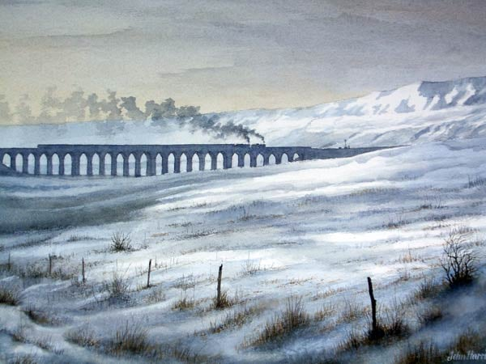

RIBBLEHEAD IN WINTER Painting by John Harris

We are indebted to Peter Blunn for contributing this evocative view of Ribblehead Viaduct in steam days. The superb painting by John Harris shows a Midland Compound piloting a Jubilee on a heavy northbound train in the stark winter landscape. Whilst the actual locomotives are unidentified, we can take a little poetic licence here as North British built 25 of the Midland Compounds and 50 of the LMS Jubilees !

Fortunately, two of the NBL Jubilees survive in preservation and the Ribblehead arches still regularly resonate to the sound of steam. One of the Midland Compounds has also been saved, a Derby product of 1902. So in theory at least, it would still be possible to re-create this scene !

As we enter 2022 many lockdown restrictions are easing around the World and our target now is to get the Hendrie 4-8-0 moved from Greenside Colliery. The move was originally delayed by the first lockdown but we are hopeful that we may be able to go ahead this year. We have already paid for the road transport but the increasing pile of coal waste that surrounds the 1A and the two 14R’s means that it may now be necessary use a crane to lift it onto a low bed. A meeting is being held on site to discuss the move and we will report back as soon as we have further news. There can be many a slip twixt cup and lip but please watch this space.
(2)
ANNIVERSARY IMAGES (photos : NB Loco Co)

In 1953 North British produced a 115 page 50th Anniversary Booklet providing a wealth of information about the firm’s history and details of the three constituent companies. A map was included showing more than 60 countries that had been supplied with locomotives. It was profusely illustrated and of course, most of the photographs were in black & white. Unusually for 1953 however, the booklet included twelve images in full colour and four of them are illustrated below showing a NZR J^{A} an LNER B1, a Diesel Electric in Ceylon and the Royal Train in Rhodesia with an NBL Class 10 at the head. (country names at the time are shown)

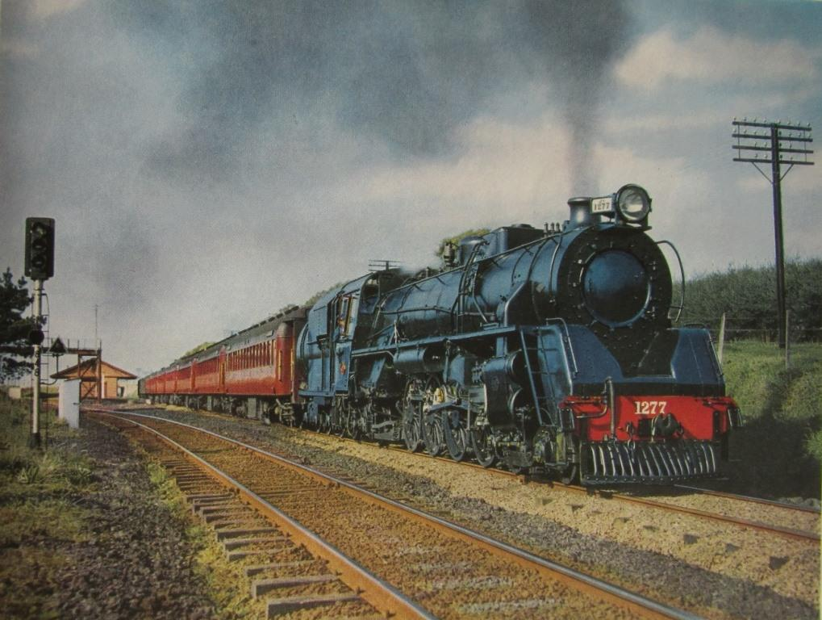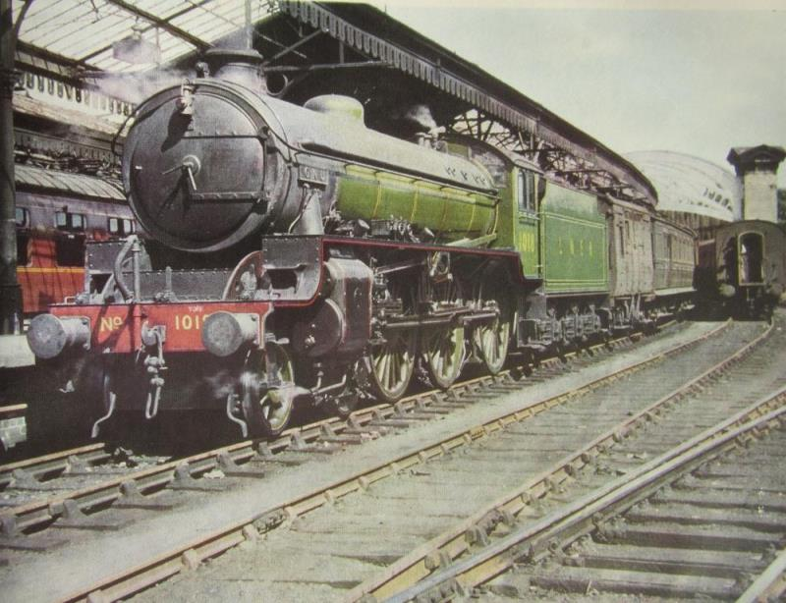
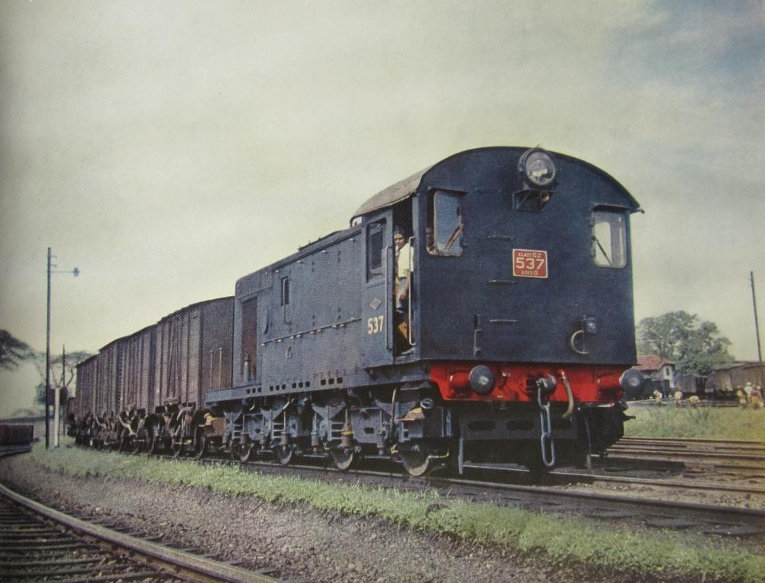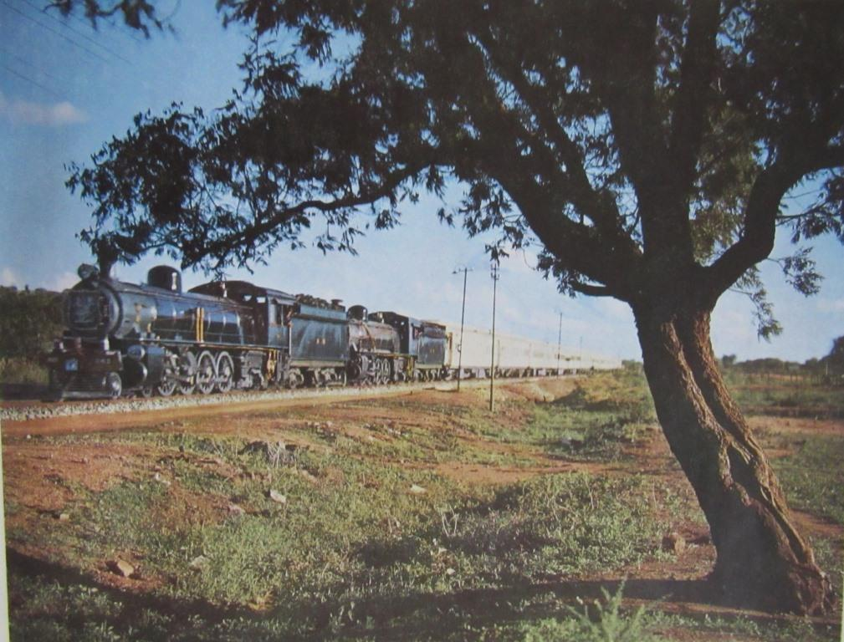

With the benefit of hindsight, the choice of some of the colour illustrations seem a little odd. For instance, given the enormous array of locomotives the publisher had to choose from, two of the twelve photos feature New Zealand Railways J^{A} Class 4-8-2’s. An even stranger choice was the photo of LNER B1 No 1018 ‘Gnu’ at York. North British built a total of 290 B1 locos and it is quite understandable that they would want to show one off in their Anniversary year but No 1018 was actually a product of the LNER Works at Darlington !
Poetic licence was also taken by featuring diamond worksplate 28000 on the cover and at several points in the booklet. Total output by 1953 had actually reached 27,587 and, given the works capacity it was probably assumed that 28,000 would passed very soon. However, with orders dwindling at home and abroad, it was to be a further 7 years before the 28,000 milestone was achieved.
Despite these comments, it is an excellent little booklet, full of interesting information and worthy of a place in any enthusiast’s library. Copies often surface in railwayana auctions and on ebay with a guide price of around £25 - £30 depending on condition. We will feature some more of the colour photos in future Newsletters.
(3)
ROVOS VISIT (photos KL Collection)

In January 2019, our NBLPG Chairman and I were treated to a visit to Rovos Rail’s private workshops in the former Capital Park loco sheds in Pretoria. Established in 1989, Rovos Rail offer a wide selection of world class luxury train journeys ranging from 48 hours to 15 days. Nowadays, most of the trains are hauled by diesel or electric locomotives but Rovos Rail own a number of steam locomotives which are sometimes used to haul specials or to add atmosphere to the main journeys.

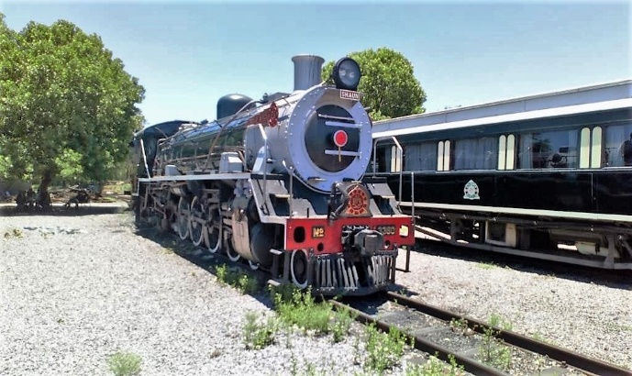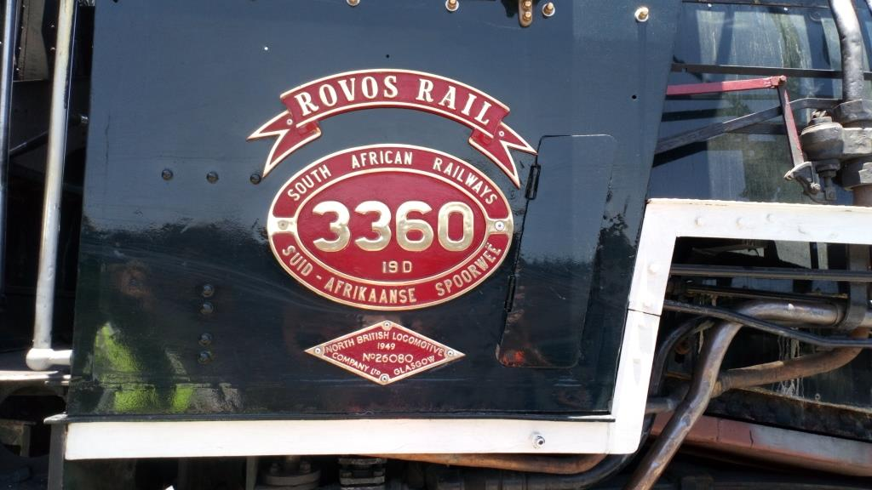

Ex SAR 19D 4-8-2 No 3360 (NB 26080) poses in steam in Capital Park yard alongside one of the beautifully restored Rovos Rail luxury coaches. The immaculate cabside plates are worthy of note. One of 50 North British 19D’s, this loco was in action in late 2021 hauling a special train to Heidelberg and back.

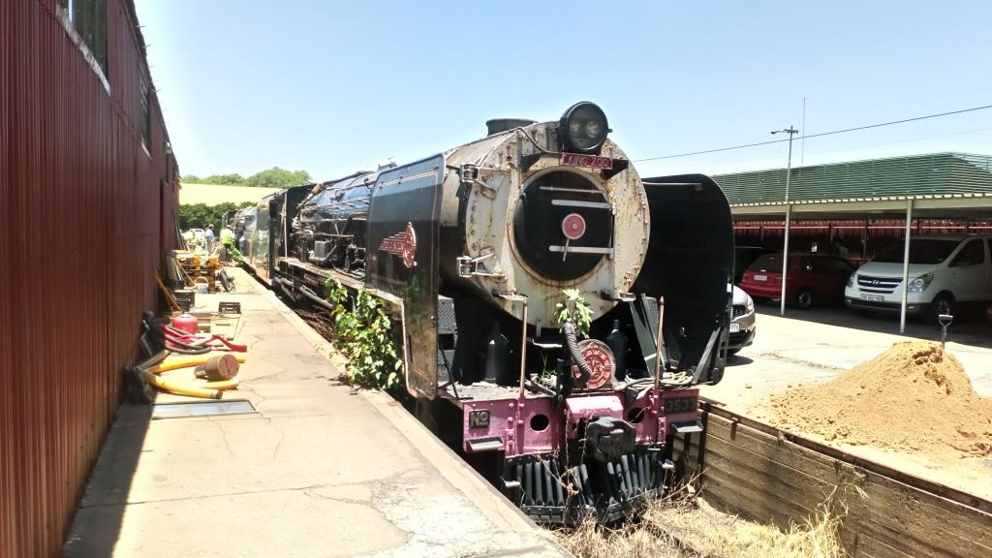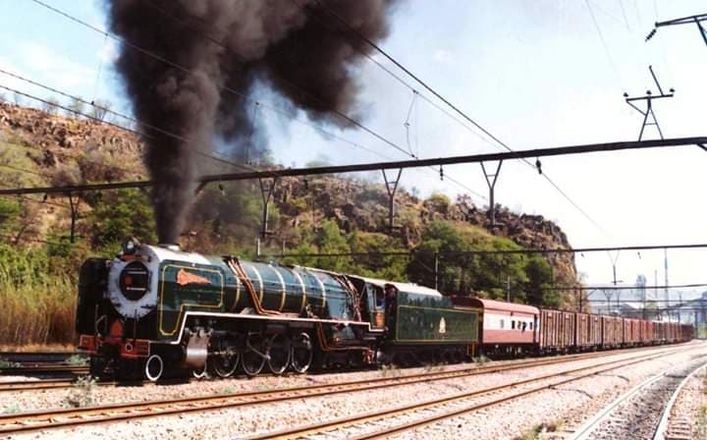

Stored at the back of the shed, hopefully awaiting a return to duty were two 25NC Class 4-8-4’s numbers 3533 (NB 27393) leading and 3442 which was built by Henschel in 1953. No 3533 is seen (above right) on a loaded test run on the outskirts of Pretoria – photo by Nathan Berelowitz.

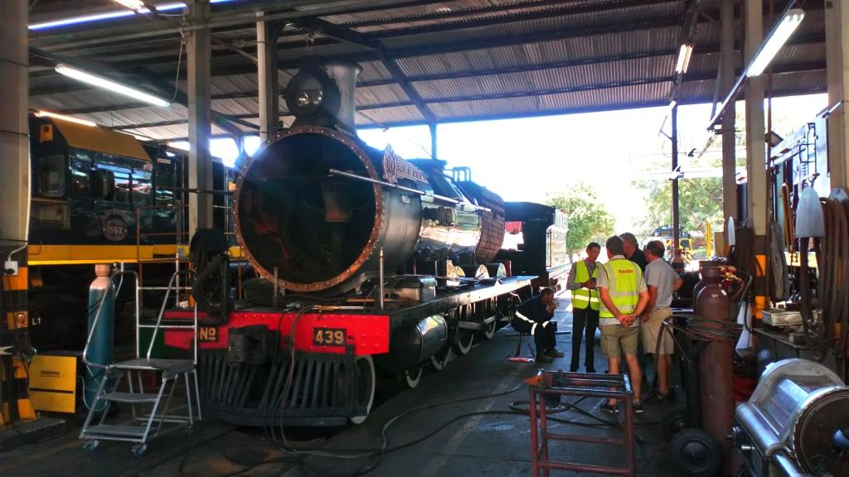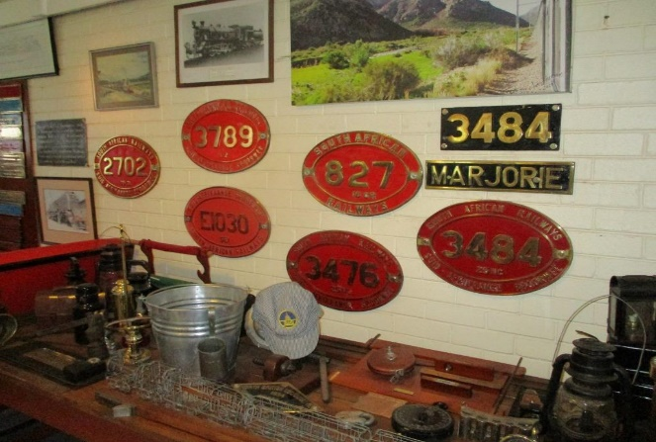

In the main running shed, Dubs 6 Class 4-6-0 No 439 (works number 3093 of 1894) was receiving major repairs which involved removal of the cab and the front of the smokebox. Our final view show some of the SAR cabside numberplates and nameplates that can be found in the Rovos Rail Museum on the site at Capital Park. More information can be found on the Rovos Rail website at : https://rovos.com
(4)
NEW ZEALAND STEAM (photos : Wilson Lythgoe)

We have included four images sent in by Wilson Lythgoe this month but they represent a significant departure from his usual delvings into the JM Creber catalogue. These photos were all taken by Wilson himself a few weeks after BR steam had ended on 30th August 1968. Several more photos were part of the attachment and these can be found on our Facebook Page at : https://www.facebook.com/NorthBritishLocomotives

First up are two views of NZR We Class 4-6-4 Tank No 375 which began life as a Sharp Stewart 4-8-0. There were only ever three We Class 4-6-4T locos and all were rebuilds of Sharp Stewart B Class locos. Two had been converted by the NZR in 1902 specifically for use on the Rimutaka Incline: one was then sent south to Greymouth to work the Rewanui Incline in 1913 with the other following in 1927. Both these locos had been withdrawn from service by the time Wilson became interested in railways in the mid-sixties. In 1943 a third Sharp Stewart B, (Works number 4510 dating from 1899), was converted by the NZR at their Hillside Workshops making the class three strong. This loco became We375 and in August 1968 was still hard at work on the Greymouth to Rewanui Branch as shown below. Sixty-nine years young and still going strong!

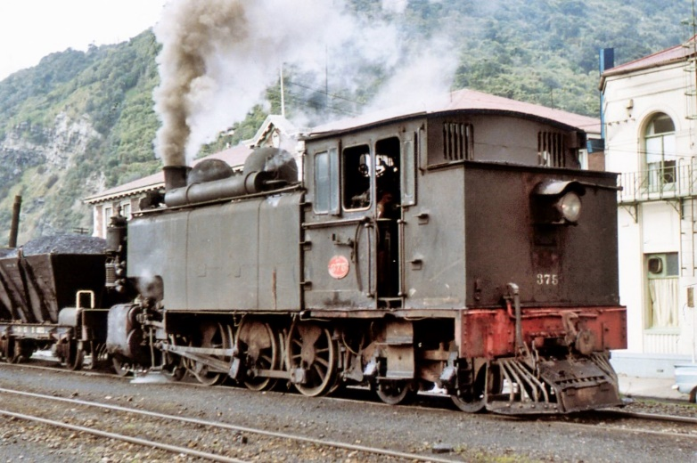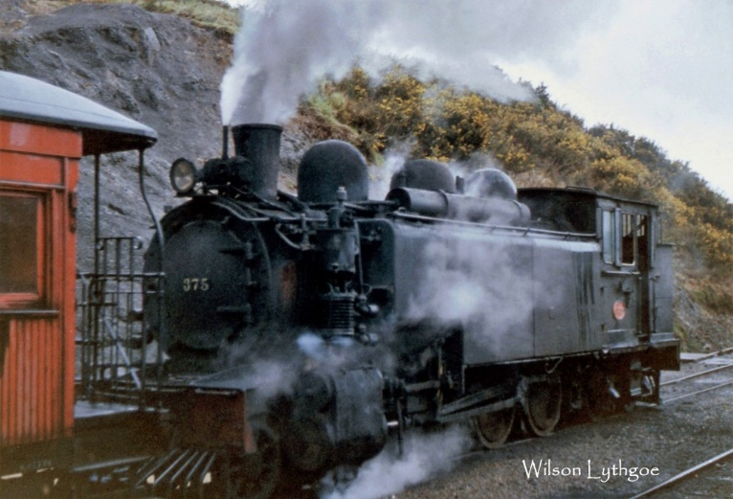

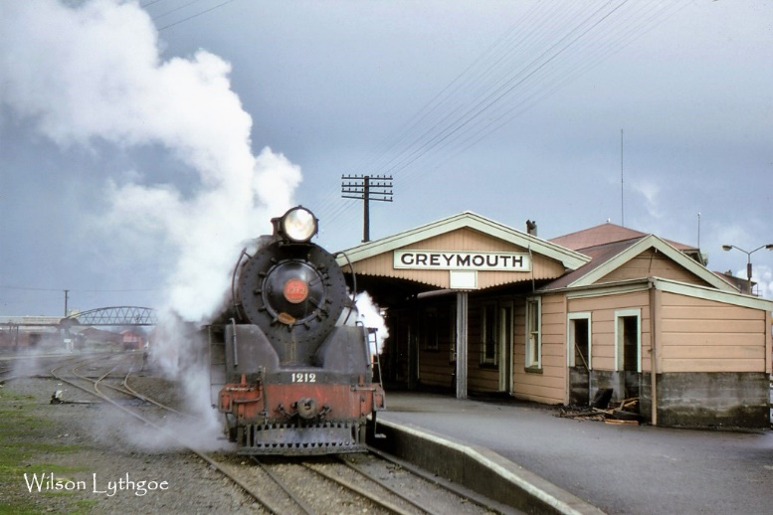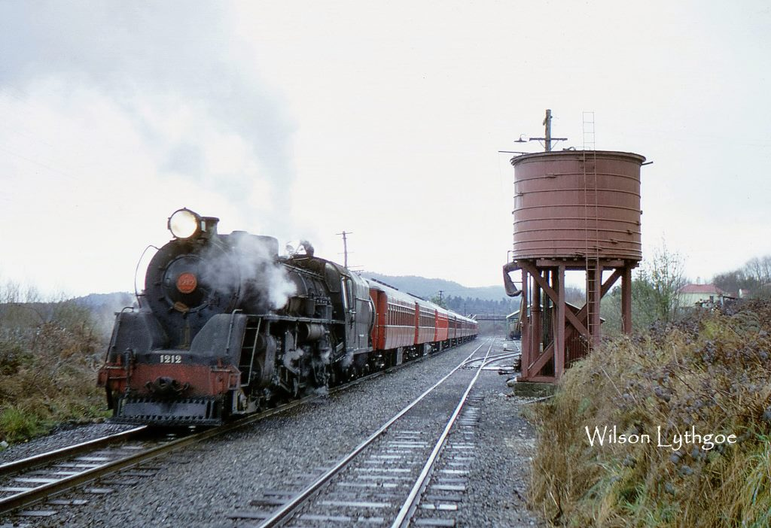

By August 1968, Railcars ran the passenger service between Christchurch and Greymouth but during school holidays and long weekends they were unable to cope with the demand for seats. When this happened, the service would be supplemented by an Express leaving soon after the railcar. With steam fast disappearing this seemed like a good opportunity to ride behind a J Class 4-8-2 on the West Coast and Wilson and a colleague did just that. Once the Ross - Christchurch railcar had departed, Train G44, with J 1212 (NB 24535) at its’ head, pulled into the main Greymouth platform to load. At ten cars and a van it was a reasonable sized train and Wilson managed to photograph it at Greymouth and at the water stop at Moana (above) before travelling on to Otira. We are out of space today but as mentioned, more of Wilson photos and a comprehensive account of this journey will appear on our Facebook Page and in future editions of our Newsletter.
(5)
NEWS IN BRIEF (photo : Barry Lowe)

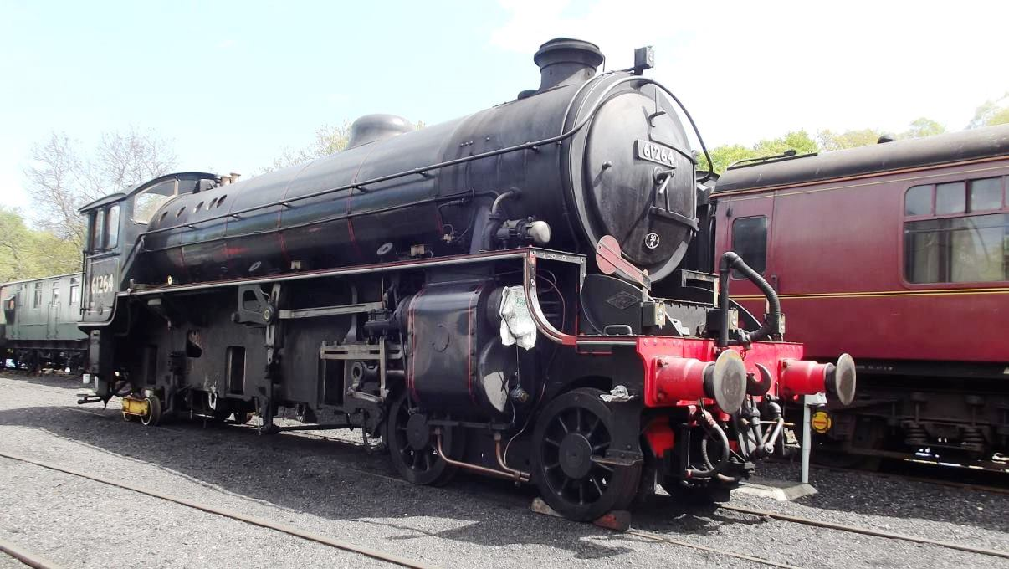
An unusual sight in Grosmont Yard on 7th January was LNER B1 4-6-0 No 61264 (NB 26165) jacked up with its’ driving wheels removed. Two of the white metal bearings in the motion needed to be replaced and it is understood that whilst this work was being carried out the opportunity was taken to have the driving wheel tyres turned. More information on the work being carried out on this loco would be greatly appreciated.
News from Livingstone Zambia is that ex Rhodesia Railways 10th class no. 156 and 12th class no. 204 (NB 22799 & 23733) are now stored out of use following a period of lease to Bushtracks Africa for use on their dining and tourist trains in the Victoria Falls area. The locos require overhaul, and Zambia Railways, the owner, wants Bushtracks to fund the work. Not an unreasonable request, but not possible in the absence of revenue as a result of the Covid pandemic. Sadly, it is likely that the locos will be parked at the railway museum in Livingstone and deteriorate.
The Sandstone Cape Gauge loco moves from Bloemfontein and Germiston have now been completed and we will bring photos of them at their new home in the next Newsletter. A video of some of the moves can be found at : https://www.facebook.com/1522411286/videos/pcb.10219147887877703/387576973060253
Sharp Stewart replica 2-4-0T ‘Blyth’ is nearing completion at North Bay Railway Engineering Services and the loco was test run on compressed air during December to check out the bearings and motion. We are all looking forward to the day when the first fire is lit and ‘Blyth’ steams into the 21st Century ! The test can be seen at : https://www.facebook.com/North-Bay-Railway-Engineering-Services-222968755125074
If you would like to comment on any of the items in this Newsletter or discuss any of the issues raised above please email ken.livermore@btinternet.com or phone me on 07990 575 103. Photos and news items for future Newsletters are always needed and can be emailed to me or posted on our Facebook page at : https://www.facebook.com/NorthBritishLocomotives
Thank you all once again for your continued support, stay safe out there !
More news to follow next month, Best Regards, Ken

Newsletter published by the NBL Preservation Group - A Not for Profit Organisation

